PRISER 4; Fråga varandra hur mycket de olika klädesplaggen kostar:

 |  | 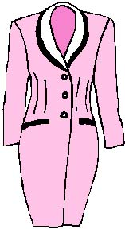
74 euros | 13 euros | 25 euros
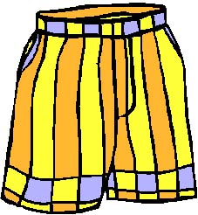 | 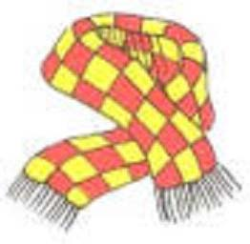 | 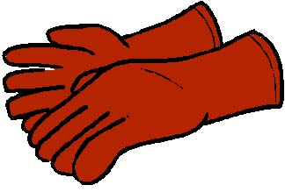
94 euros | 12 euros | 22 euros
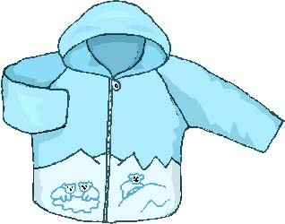 | 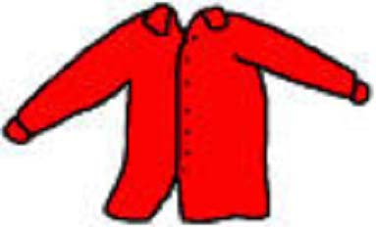 | 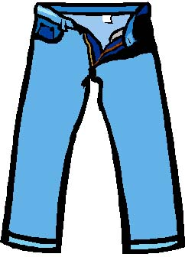
55 euros | 49 euros | 19 euros
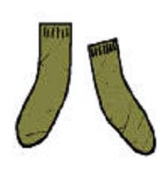 | 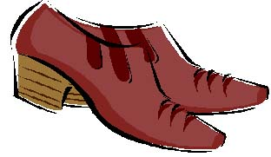 | 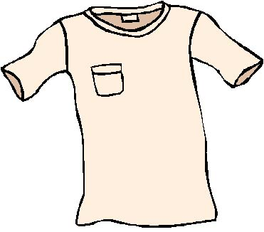
11 euros | 16 euros | 77 euros
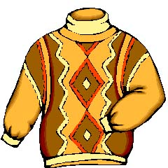 | 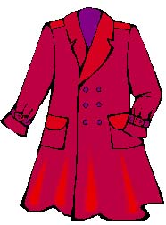 | 
42 euros | 17 euros | 6 euros
´
VÊTEMENTS:

.............jupe (schypp) | ............chapeau (schapå) | ............robe (råbb)
.............short | .............écharpe (escharp) | .............gant (gaaaaa)
..............blouson (blozååå) | ............chemise (schömiz) | ..............pantalon (paaantalåå)
.............chaussette (schåssätt) | ............chaussure (schåssyr) | ............maillot (majjååå)
.............pull (pyll) | ..............manteau (maaaantåå) | .............casquette (kasskätt)

