2034 DÉCRIVEZ LES IMAGES 2

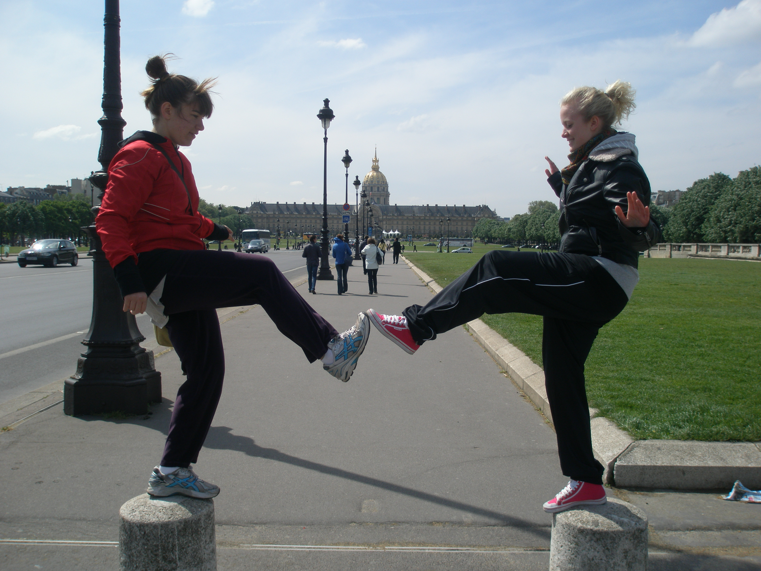

______________________________________________________________________________________

______________________________________________________________________________________

______________________________________________________________________________________

______________________________________________________________________________________

______________________________________________________________________________________

______________________________________________________________________________________

______________________________________________________________________________________

______________________________________________________________________________________

______________________________________________________________________________________

______________________________________________________________________________________

______________________________________________________________________________________

______________________________________________________________________________________

______________________________________________________________________________________

______________________________________________________________________________________

______________________________________________________________________________________

______________________________________________________________________________________

DÉCRIVEZ LES IMAGES 3



































