ÖVERSÄTT DENNA TEXT SKRIFTLIGT TILL SVENSKA:

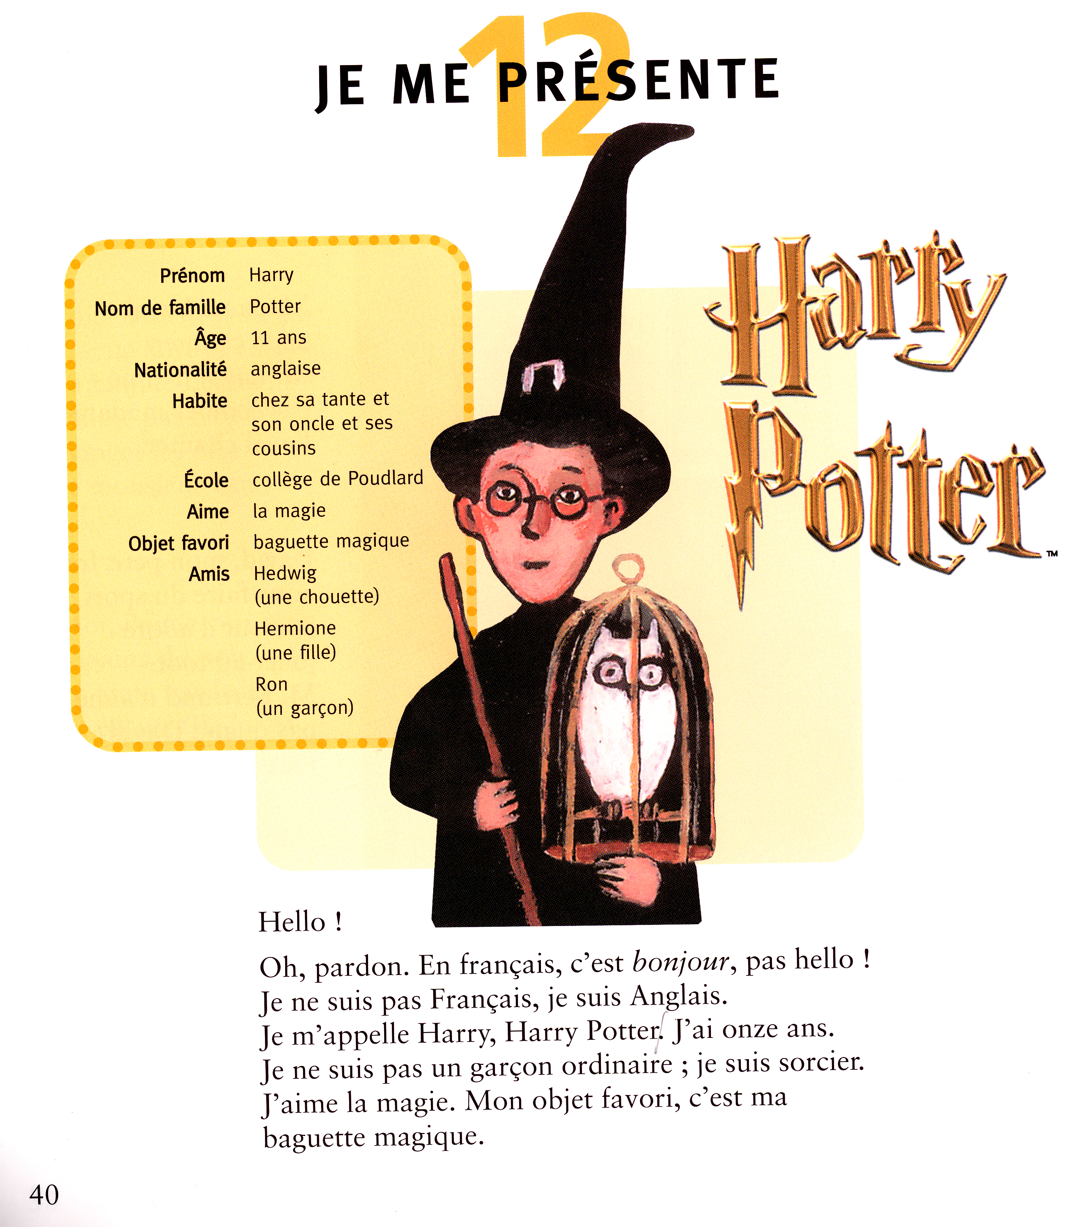

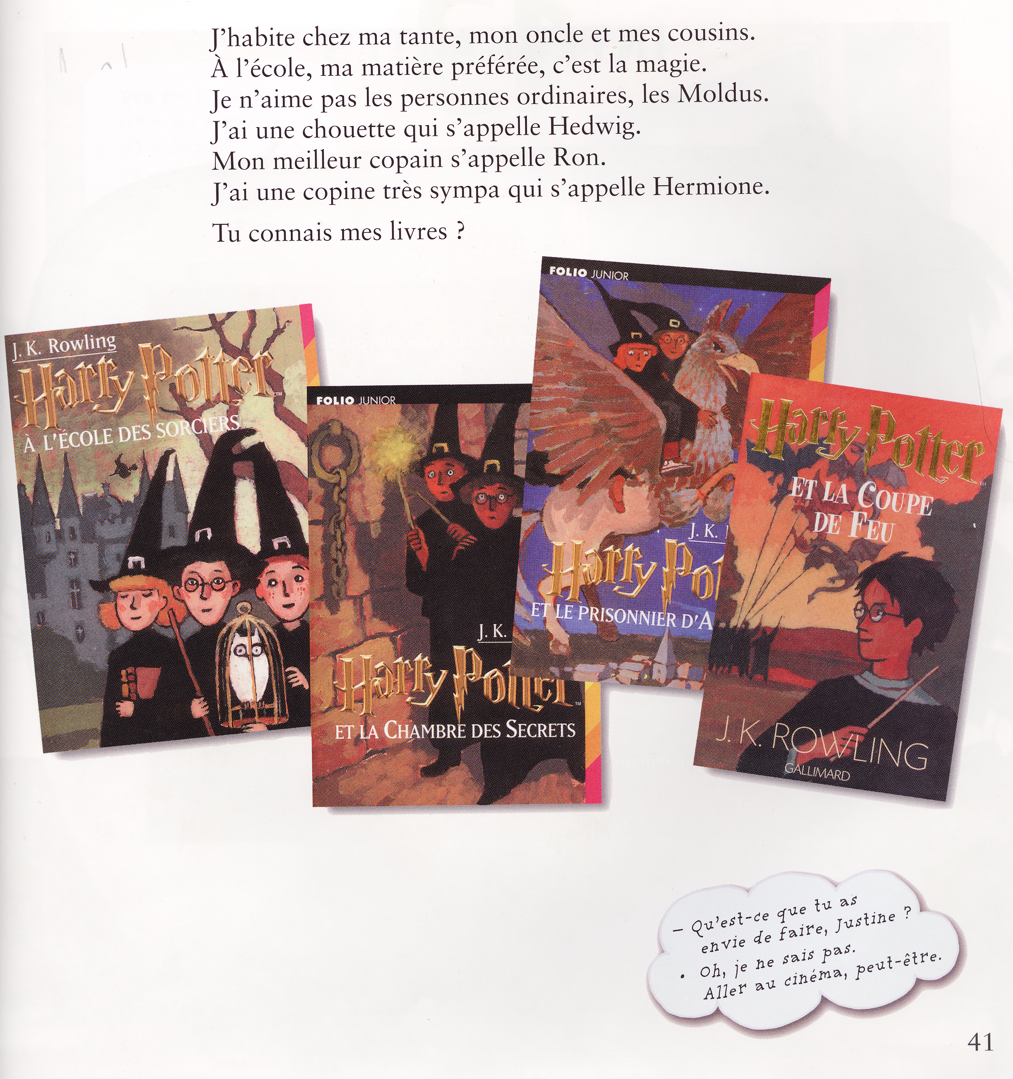

_________________________________________________________________________________________

_________________________________________________________________________________________

_________________________________________________________________________________________

_________________________________________________________________________________________

_________________________________________________________________________________________

_________________________________________________________________________________________

_________________________________________________________________________________________

_________________________________________________________________________________________

_________________________________________________________________________________________

_________________________________________________________________________________________

_________________________________________________________________________________________

_________________________________________________________________________________________

_________________________________________________________________________________________

_________________________________________________________________________________________

_________________________________________________________________________________________

_________________________________________________________________________________________

_________________________________________________________________________________________

_________________________________________________________________________________________

_________________________________________________________________________________________

_________________________________________________________________________________________

_________________________________________________________________________________________

_________________________________________________________________________________________

_________________________________________________________________________________________

_________________________________________________________________________________________

_________________________________________________________________________________________

_________________________________________________________________________________________

_________________________________________________________________________________________

_________________________________________________________________________________________

_________________________________________________________________________________________

_________________________________________________________________________________________

_________________________________________________________________________________________

_________________________________________________________________________________________

_________________________________________________________________________________________

_________________________________________________________________________________________

_________________________________________________________________________________________

_________________________________________________________________________________________

_________________________________________________________________________________________

ALLEZ HOP! classe 5ème; chapitre 12
chapitre 12 | kapitel 12
je me présente (av présenter) | jag presenterar mig
le prénom | förnamnet
le nom de famille | efternamnet
un âge | en ålder
la nationalité | nationaliteten
anglais -e | engelsk
chez | hos
sa tante | hans (sin) moster/faster
son oncle | hans (sin) morbror/farbror
ses cousins | hans (sina) kusiner
la magie | trollkonsten, magin
un objet favori | ett favoritföremål
la baguette magique | trollspöet
un ami | en vän
la chouette | ugglan
qui | som, vem
le Français | fransmannen
un Anglais | engelsmannen
ordinaire | vanlig
le sorcier | trollkarlen
à l'école | i skolan
ma matière préférée | mitt älsklingsämne, mitt bästa ämne
la personne | personen
les Moldus | mugglare
mon meilleur copain | min bästa kompis
la copine | (flick)kompisen
sympa | trevlig
tu connais? (av connaître) | känner du till
mes livres | mina böcker
tu as envie (de) | du har lust (att)
je ne sais pas | jag vet inte
aller au cinéma | gå på bio
peut-être | kanske

