**les fruits et les légumes**

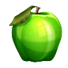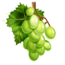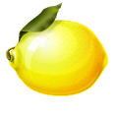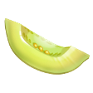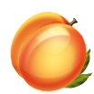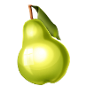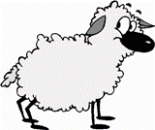

**WORDS IN SINGULAR:**

**leaf strawberry**

**cherry sheep**

**person shelf**

**watch paintbrush**

**fox mouse**

**match puppy**

**knife tomato**

**loaf glass**

**potato sandwich**

**fish**

