décrire des images 1
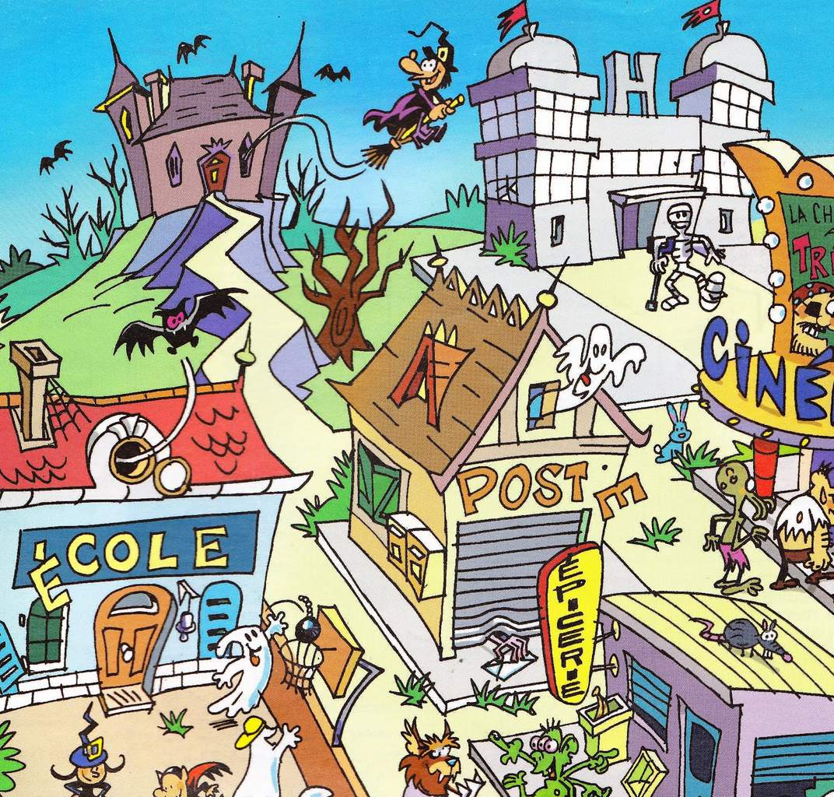
______________________________________________________________________________________________

______________________________________________________________________________________________

______________________________________________________________________________________________

______________________________________________________________________________________________

______________________________________________________________________________________________

______________________________________________________________________________________________

______________________________________________________________________________________________

______________________________________________________________________________________________

______________________________________________________________________________________________

______________________________________________________________________________________________

______________________________________________________________________________________________

______________________________________________________________________________________________
décrire des images 2
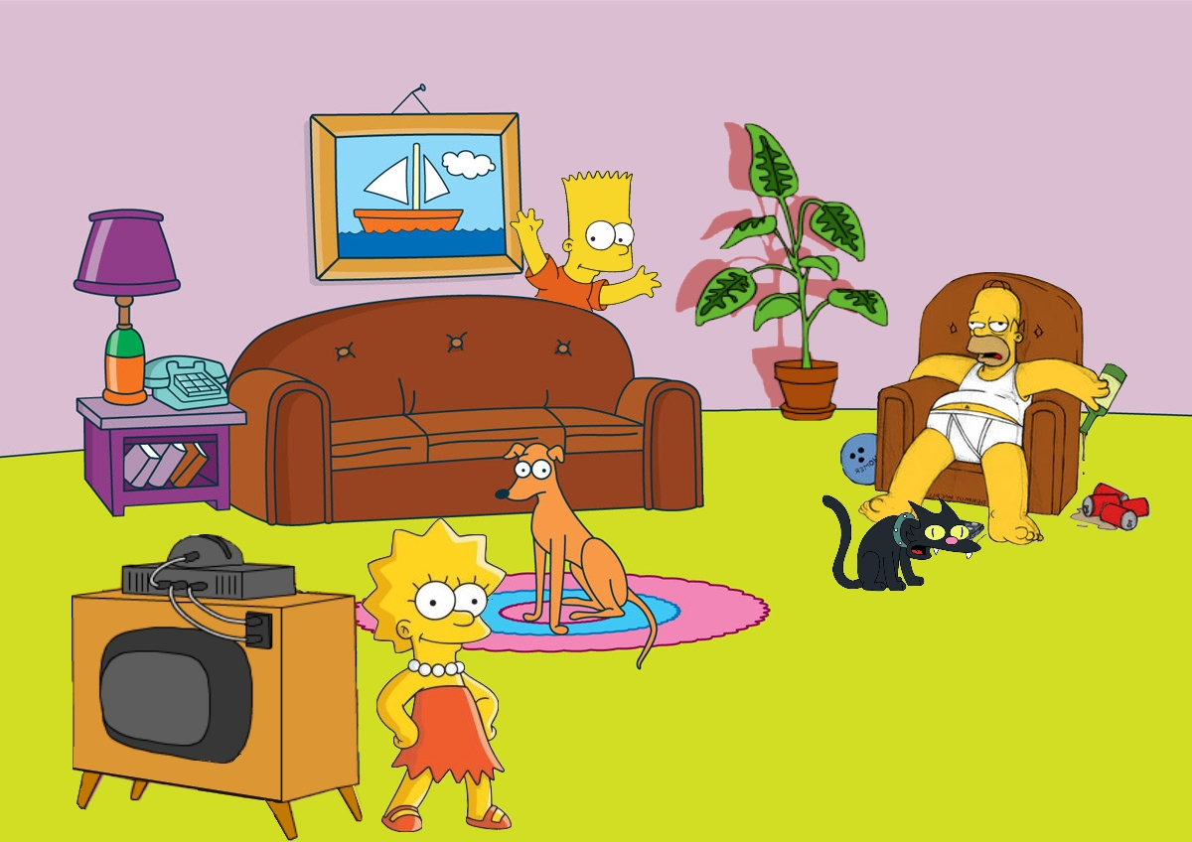
______________________________________________________________________________________________

______________________________________________________________________________________________

______________________________________________________________________________________________

______________________________________________________________________________________________

______________________________________________________________________________________________

______________________________________________________________________________________________

______________________________________________________________________________________________

______________________________________________________________________________________________

______________________________________________________________________________________________

______________________________________________________________________________________________

______________________________________________________________________________________________

______________________________________________________________________________________________

______________________________________________________________________________________________

______________________________________________________________________________________________

______________________________________________________________________________________________

______________________________________________________________________________________________

______________________________________________________________________________________________

décrire des images 3











































