décrire des images 17
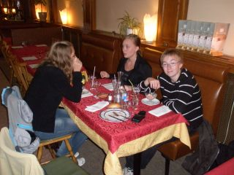
manger-boire-discuter-être assis-terminer-content-repu-veste-nappe
______________________________________________________________________________________________

______________________________________________________________________________________________

______________________________________________________________________________________________

______________________________________________________________________________________________

______________________________________________________________________________________________

______________________________________________________________________________________________

______________________________________________________________________________________________

______________________________________________________________________________________________

______________________________________________________________________________________________

______________________________________________________________________________________________

______________________________________________________________________________________________

______________________________________________________________________________________________

______________________________________________________________________________________________

______________________________________________________________________________________________

______________________________________________________________________________________________

décrire des images 18
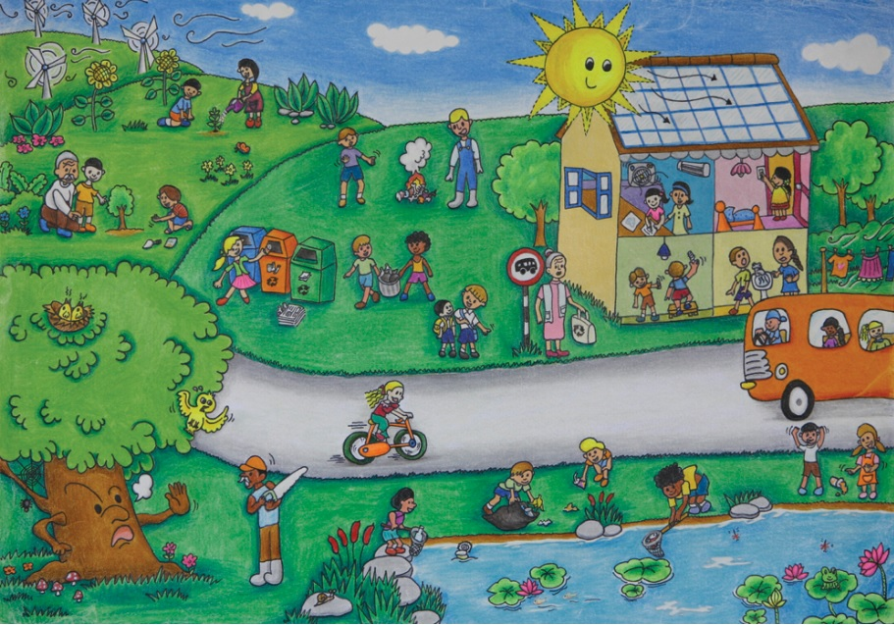
arbre-faire du vélo-nénuphar-scie-arrêt de bus-poubelle-un étang-le linge-attendre-herbe-un feu-éolienne
______________________________________________________________________________________________

______________________________________________________________________________________________

______________________________________________________________________________________________

______________________________________________________________________________________________

______________________________________________________________________________________________

______________________________________________________________________________________________

______________________________________________________________________________________________

______________________________________________________________________________________________

______________________________________________________________________________________________

______________________________________________________________________________________________

______________________________________________________________________________________________

______________________________________________________________________________________________

______________________________________________________________________________________________

______________________________________________________________________________________________

______________________________________________________________________________________________

______________________________________________________________________________________________

