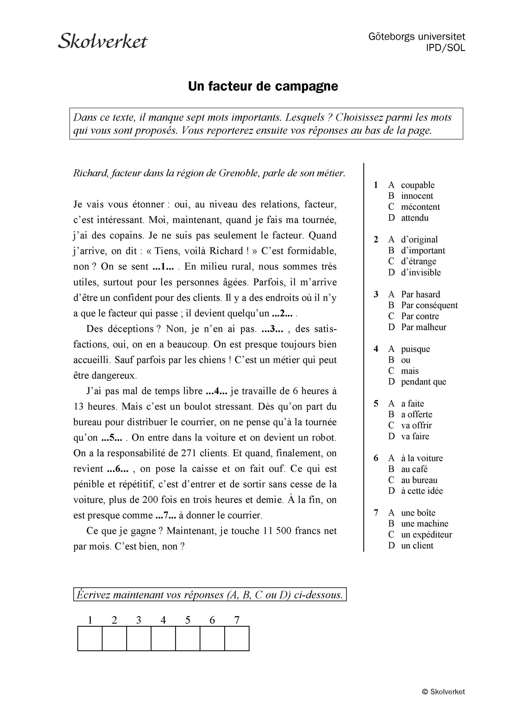
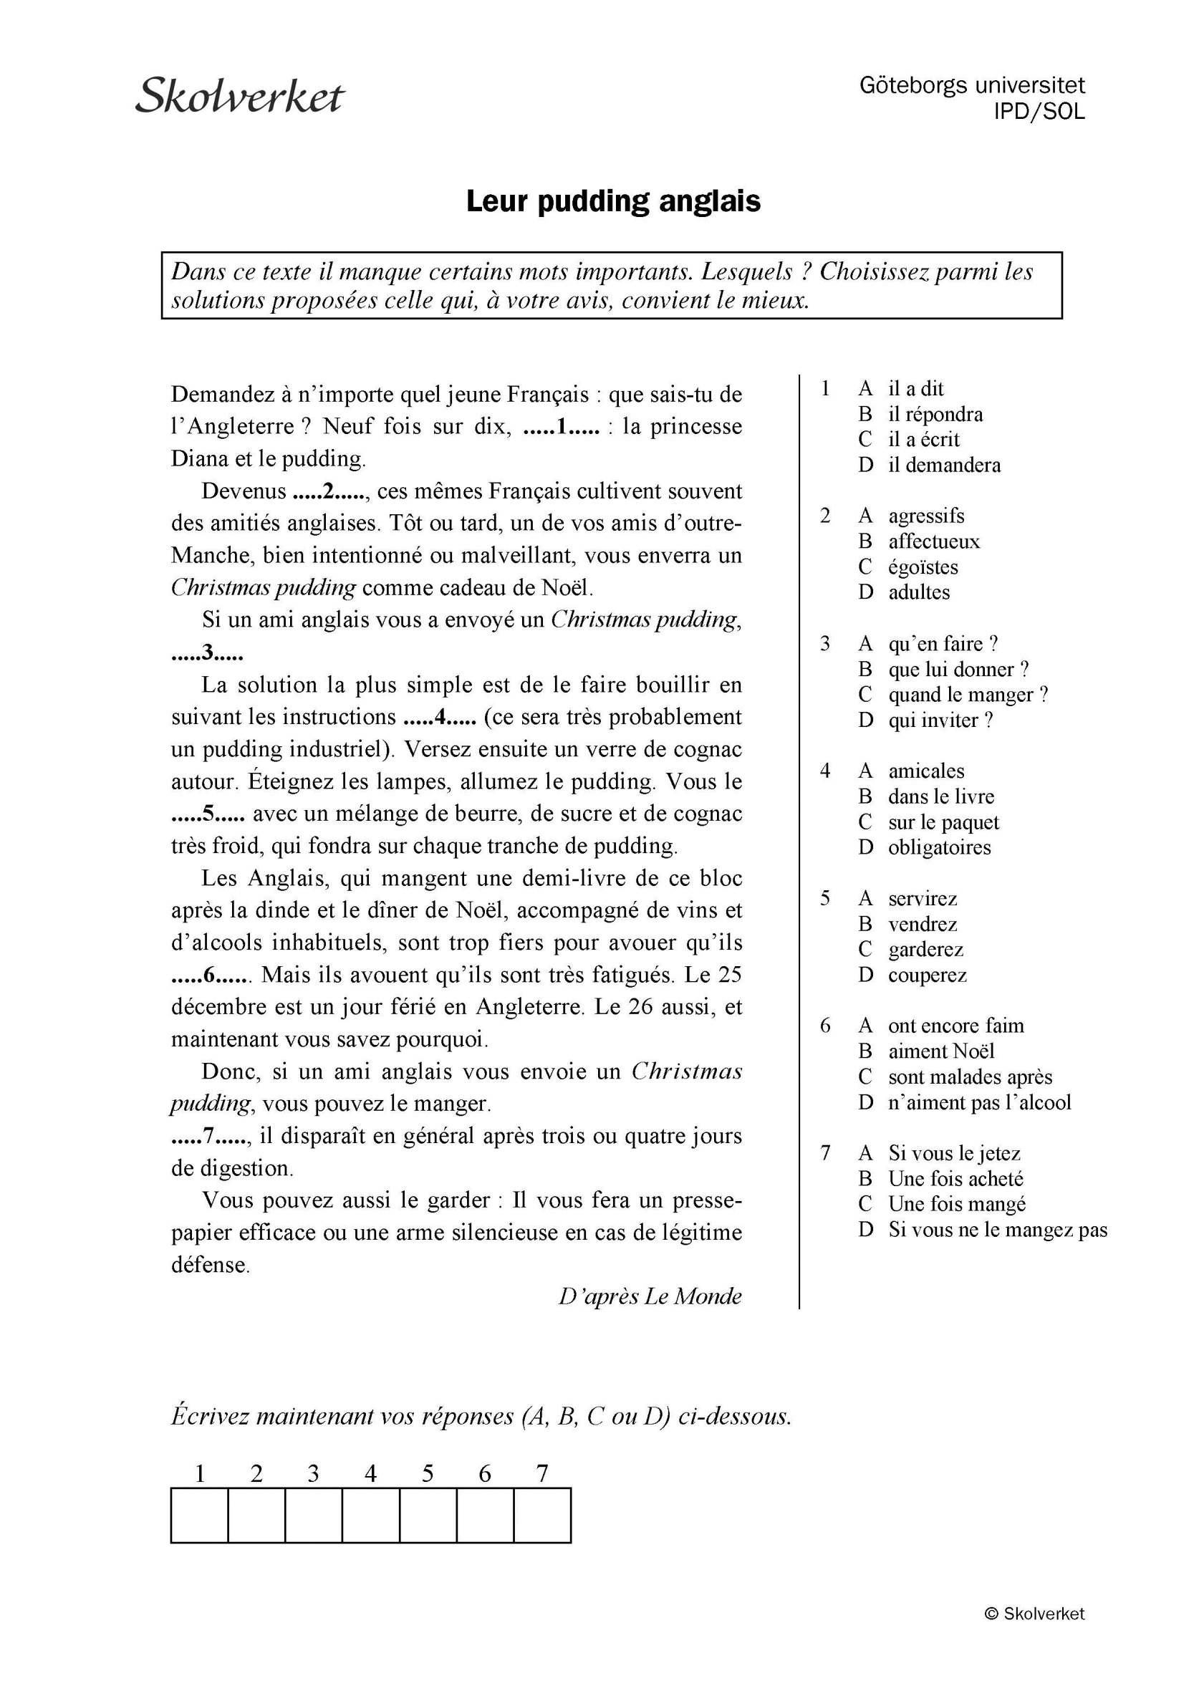

RÉDACTION; skriv och berätta om minst 3 av följande franska fenomen: la Tour Eiffel, les calissons, les macarons, le Bibendum, le Notre Dame, la truffe, Plus Belle La Vie, Fort Boyard, le Père Lachaise ; skriv mycket !
___________________________________________________________________________________________________
___________________________________________________________________________________________________
___________________________________________________________________________________________________
___________________________________________________________________________________________________
___________________________________________________________________________________________________
___________________________________________________________________________________________________
___________________________________________________________________________________________________
___________________________________________________________________________________________________
___________________________________________________________________________________________________
___________________________________________________________________________________________________
___________________________________________________________________________________________________
___________________________________________________________________________________________________
___________________________________________________________________________________________________
___________________________________________________________________________________________________
___________________________________________________________________________________________________
___________________________________________________________________________________________________
___________________________________________________________________________________________________
___________________________________________________________________________________________________
___________________________________________________________________________________________________
___________________________________________________________________________________________________
___________________________________________________________________________________________________
___________________________________________________________________________________________________
___________________________________________________________________________________________________
___________________________________________________________________________________________________
___________________________________________________________________________________________________
___________________________________________________________________________________________________
___________________________________________________________________________________________________
___________________________________________________________________________________________________
___________________________________________________________________________________________________
___________________________________________________________________________________________________
___________________________________________________________________________________________________
___________________________________________________________________________________________________
___________________________________________________________________________________________________
___________________________________________________________________________________________________
___________________________________________________________________________________________________
___________________________________________________________________________________________________
___________________________________________________________________________________________________
___________________________________________________________________________________________________
___________________________________________________________________________________________________
___________________________________________________________________________________________________
___________________________________________________________________________________________________
___________________________________________________________________________________________________
___________________________________________________________________________________________________
___________________________________________________________________________________________________
___________________________________________________________________________________________________
___________________________________________________________________________________________________
___________________________________________________________________________________________________
___________________________________________________________________________________________________
___________________________________________________________________________________________________
___________________________________________________________________________________________________
___________________________________________________________________________________________________
___________________________________________________________________________________________________
___________________________________________________________________________________________________
___________________________________________________________________________________________________
___________________________________________________________________________________________________
___________________________________________________________________________________________________
___________________________________________________________________________________________________
___________________________________________________________________________________________________
___________________________________________________________________________________________________
___________________________________________________________________________________________________
___________________________________________________________________________________________________
___________________________________________________________________________________________________
___________________________________________________________________________________________________
___________________________________________________________________________________________________
___________________________________________________________________________________________________
___________________________________________________________________________________________________
___________________________________________________________________________________________________
___________________________________________________________________________________________________
___________________________________________________________________________________________________
___________________________________________________________________________________________________
___________________________________________________________________________________________________
___________________________________________________________________________________________________
___________________________________________________________________________________________________
___________________________________________________________________________________________________
___________________________________________________________________________________________________
___________________________________________________________________________________________________
___________________________________________________________________________________________________
___________________________________________________________________________________________________
___________________________________________________________________________________________________
___________________________________________________________________________________________________
___________________________________________________________________________________________________
___________________________________________________________________________________________________
___________________________________________________________________________________________________
___________________________________________________________________________________________________
___________________________________________________________________________________________________
___________________________________________________________________________________________________
___________________________________________________________________________________________________
___________________________________________________________________________________________________
___________________________________________________________________________________________________
___________________________________________________________________________________________________
___________________________________________________________________________________________________
___________________________________________________________________________________________________
___________________________________________________________________________________________________
___________________________________________________________________________________________________

