Q1.Trouvez les mots en français

T | L | D | K | L | W | D | G | G | C
O | I | U | Y | X | D | C | A | N | H
M | T | R | U | C | R | V | R | I | A
M | A | E | I | R | E | B | C | O | I
E | B | W | O | A | G | G | O | P | S
J | L | S | T | Y | L | O | N | Z | E
E | E | S | L | O | E | M | D | L | Q
R | K | A | R | N | Y | M | F | I | A
G | C | H | A | I | S | E | T | V | Z
F | L | S | D | R | A | V | G | R | C
B | V | X | F | B | F | C | N | E | T

Q2..
- S L F A S F M S F P S E S F
__________________________________
2.F A S F R S B S F R S F E
___________________________________
- S F C S F A S H S I S E F R S F
_____________________________________
Q3. Ecrivez en francais
1.___________________2. __________________

Q4. Répondez
- Quel age as- tu?
_____________________________________________________.
2.Comment tu t’appelles ?
______________________________________________________.
3.Comment ca va ?
______________________________________________________.
- Ou habites – tu?
______________________________________________________.

Q5. Reliez les nombres.
1. 4 neuf
2. 16 quatre
3. 19 douze
4.12 Seize
5. 9 dix -neuf

Q6. Compte et écrivez en français.
1.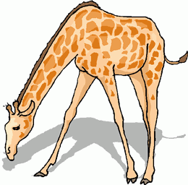_________________
2.  ___________________________
3.  ___________________

