Ecrivez les verbes.

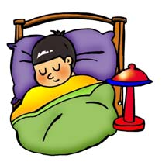 | 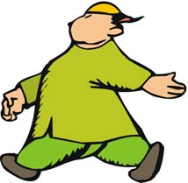 | 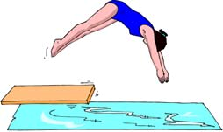 | 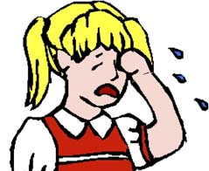 | 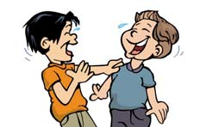 | 
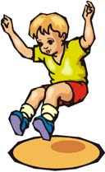 |  | 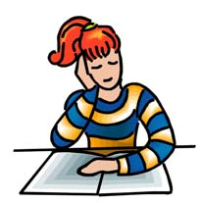 | 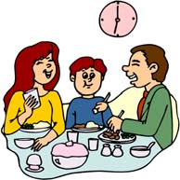 | 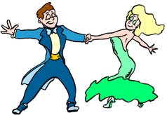 | 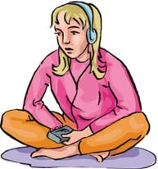
 | 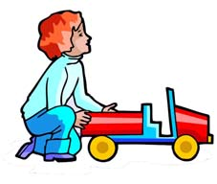 |  | 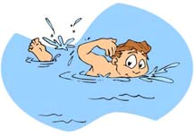 | 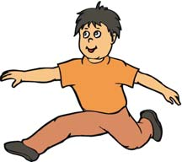 | 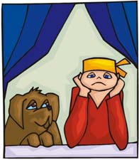
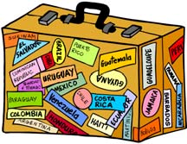 | 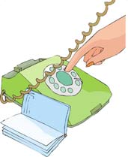 | 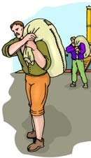 | 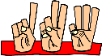 |  | 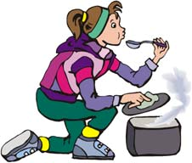

Q1. Identifiez les verbes et écrivez a la forme infinitif.
Q2. Faites des phrases utilisant les verbes.
______________________________________________________________________________
____________________________________________________________________________________________________________________________________________________________________________________________________________________________________________________________________________________________________________________________________________________________________________________________________________________________________________________________________________________________________________________________________________________________________________________________________________________________________________________________________________________________________________________________________________________________________________________________________________________________________________________________________________________________________________________________________________________________________________________________________________________________________________________________________________________________________________________________________________________________________________________________________________________________________________________________________________________________________________________________________________________________________________________________________________________________________________________________________________________________________________________________________________________________________________________________________________________________________________________________________________________________________________________________________________________________________________________________________________________________________________________________________________________________________________________________________________________________________________________________________________________________________________________________________________________________________________

