DÉCRIRE ET DISCUTER 6a

Que voyez-vous sur ces images ? Décrivez-les en détail !

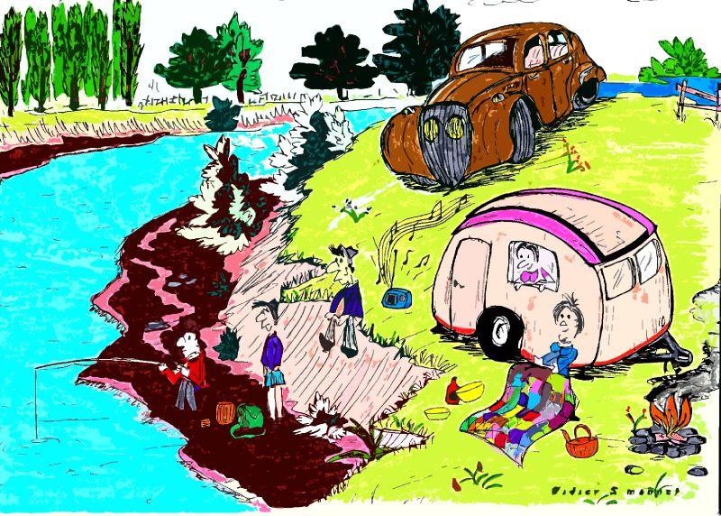

______________________________________________________________________________________

______________________________________________________________________________________

______________________________________________________________________________________

______________________________________________________________________________________

______________________________________________________________________________________

______________________________________________________________________________________

______________________________________________________________________________________

______________________________________________________________________________________

______________________________________________________________________________________

______________________________________________________________________________________

______________________________________________________________________________________

______________________________________________________________________________________

______________________________________________________________________________________

______________________________________________________________________________________

______________________________________________________________________________________

______________________________________________________________________________________
DÉCRIRE ET DISCUTER 6b













































