4502 DÉCRIRE DES IMAGES 1

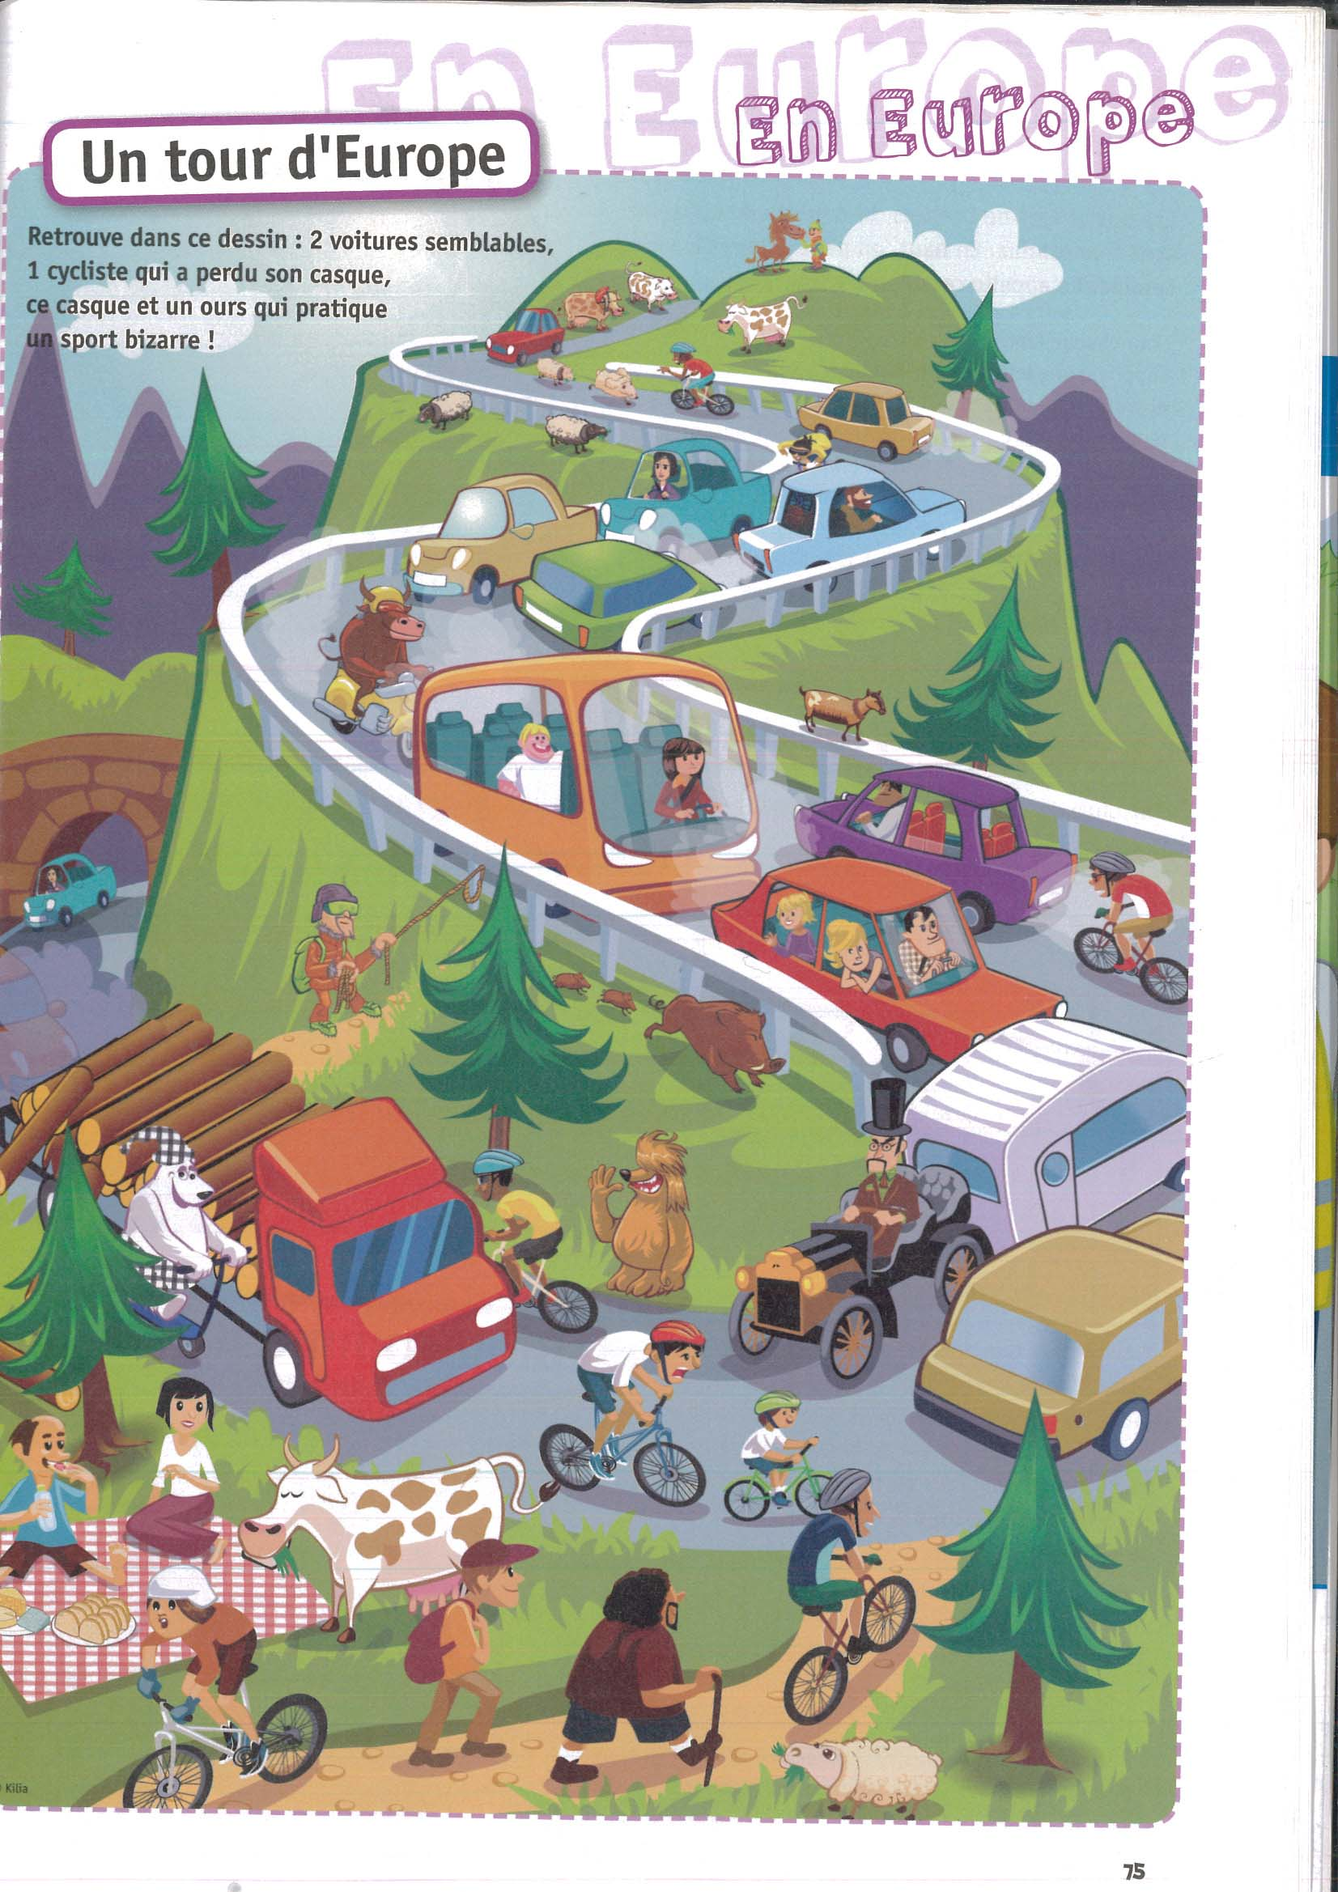

______________________________________________________________________________________

______________________________________________________________________________________

______________________________________________________________________________________

______________________________________________________________________________________

______________________________________________________________________________________

______________________________________________________________________________________

______________________________________________________________________________________

______________________________________________________________________________________

______________________________________________________________________________________

______________________________________________________________________________________

______________________________________________________________________________________

______________________________________________________________________________________

______________________________________________________________________________________

______________________________________________________________________________________

______________________________________________________________________________________

______________________________________________________________________________________

______________________________________________________________________________________

______________________________________________________________________________________

______________________________________________________________________________________

______________________________________________________________________________________

______________________________________________________________________________________

______________________________________________________________________________________

______________________________________________________________________________________

______________________________________________________________________________________

______________________________________________________________________________________

______________________________________________________________________________________

______________________________________________________________________________________

______________________________________________________________________________________

______________________________________________________________________________________

______________________________________________________________________________________

______________________________________________________________________________________

______________________________________________________________________________________

______________________________________________________________________________________

______________________________________________________________________________________

______________________________________________________________________________________
4502 DÉCRIRE DES IMAGES 2

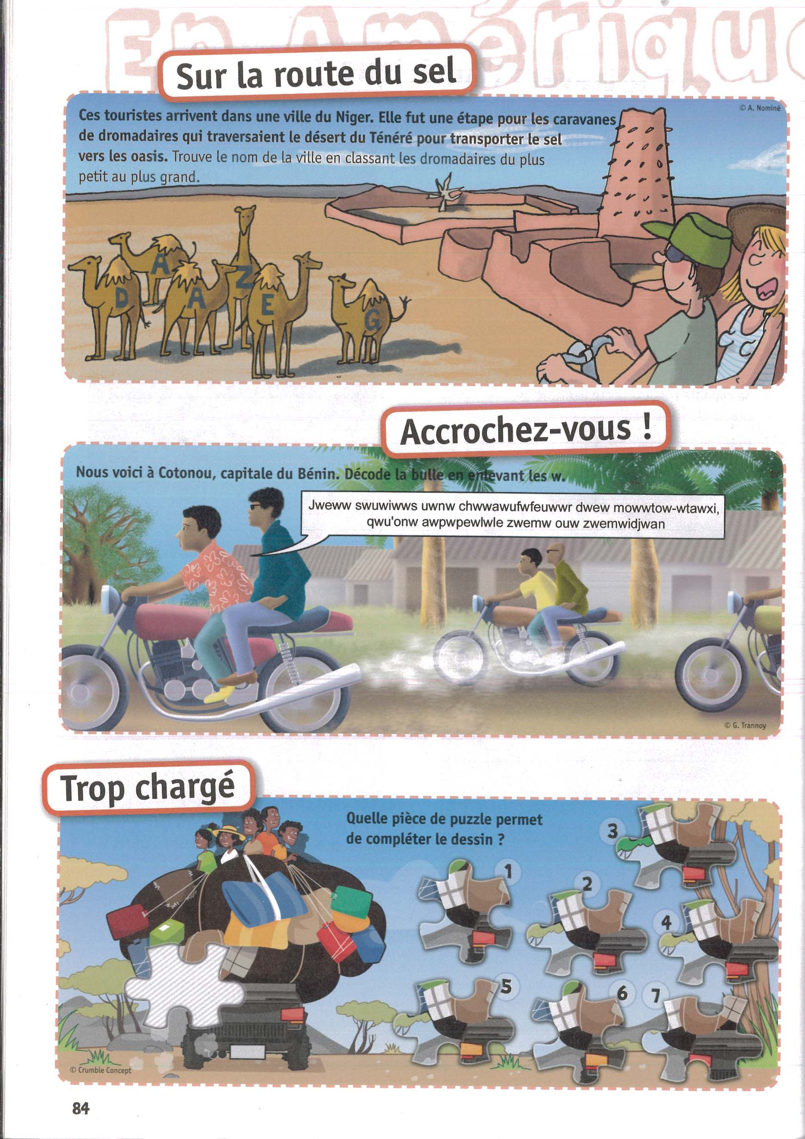

4502 DÉCRIRE DES IMAGES 3

