DÉCRIRE DES IMAGES 1



posez des questions sur l’image:

______________________________________________________________________________________

______________________________________________________________________________________

______________________________________________________________________________________

______________________________________________________________________________________

______________________________________________________________________________________

______________________________________________________________________________________
DÉCRIRE DES IMAGES 2
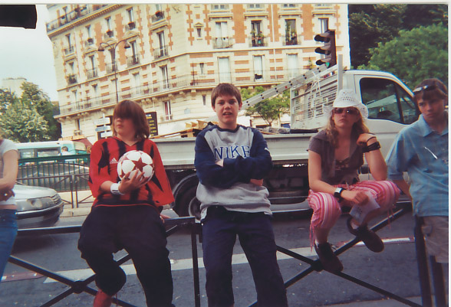

posez des questions sur l’image:

______________________________________________________________________________________

______________________________________________________________________________________

______________________________________________________________________________________

______________________________________________________________________________________

______________________________________________________________________________________

______________________________________________________________________________________

______________________________________________________________________________________

______________________________________________________________________________________

______________________________________________________________________________________

______________________________________________________________________________________

______________________________________________________________________________________

______________________________________________________________________________________

______________________________________________________________________________________

______________________________________________________________________________________

DÉCRIRE DES IMAGES 3
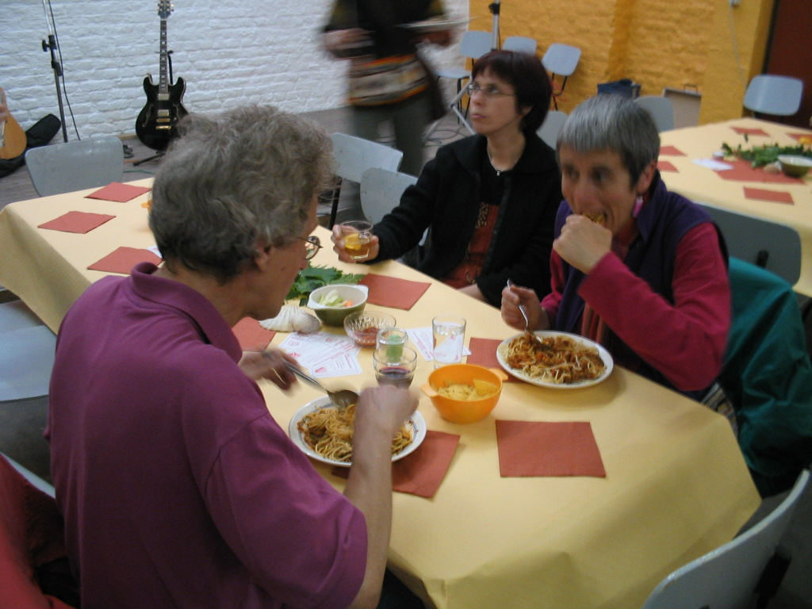

posez des questions sur l’image:

______________________________________________________________________________________

______________________________________________________________________________________

______________________________________________________________________________________

______________________________________________________________________________________

______________________________________________________________________________________

______________________________________________________________________________________

______________________________________________________________________________________

______________________________________________________________________________________

______________________________________________________________________________________

______________________________________________________________________________________

______________________________________________________________________________________

______________________________________________________________________________________

______________________________________________________________________________________

______________________________________________________________________________________

DÉCRIRE DES IMAGES 4
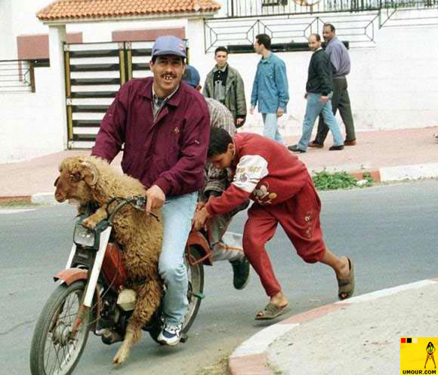

posez des questions sur l’image:

______________________________________________________________________________________

______________________________________________________________________________________

______________________________________________________________________________________

______________________________________________________________________________________

______________________________________________________________________________________

______________________________________________________________________________________

______________________________________________________________________________________

______________________________________________________________________________________

______________________________________________________________________________________

______________________________________________________________________________________

______________________________________________________________________________________

______________________________________________________________________________________

______________________________________________________________________________________

______________________________________________________________________________________
DÉCRIRE DES IMAGES 5

