DÉCRIRE DES IMAGES; beskriv denna bild så utförligt som möjligt 11
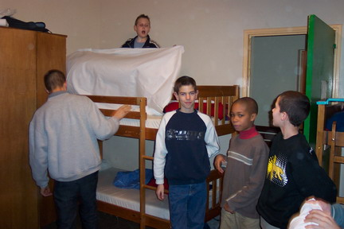

______________________________________________________________________________________

______________________________________________________________________________________

______________________________________________________________________________________

______________________________________________________________________________________

______________________________________________________________________________________

______________________________________________________________________________________

______________________________________________________________________________________

______________________________________________________________________________________

______________________________________________________________________________________

______________________________________________________________________________________

______________________________________________________________________________________

______________________________________________________________________________________

______________________________________________________________________________________

______________________________________________________________________________________

______________________________________________________________________________________

______________________________________________________________________________________

DÉCRIRE DES IMAGES; beskriv denna bild så utförligt som möjligt 12

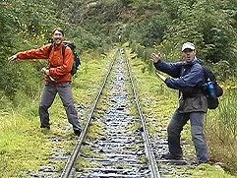

______________________________________________________________________________________

______________________________________________________________________________________

______________________________________________________________________________________

______________________________________________________________________________________

______________________________________________________________________________________

______________________________________________________________________________________

______________________________________________________________________________________

______________________________________________________________________________________

______________________________________________________________________________________

______________________________________________________________________________________

______________________________________________________________________________________

______________________________________________________________________________________

______________________________________________________________________________________

______________________________________________________________________________________

______________________________________________________________________________________
DÉCRIRE DES IMAGES; beskriv denna bild så utförligt som möjligt 13
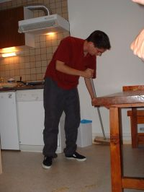

______________________________________________________________________________________

______________________________________________________________________________________

______________________________________________________________________________________

______________________________________________________________________________________

______________________________________________________________________________________

______________________________________________________________________________________

______________________________________________________________________________________

______________________________________________________________________________________

______________________________________________________________________________________

______________________________________________________________________________________

DÉCRIRE DES IMAGES; beskriv denna bild så utförligt som möjligt 14
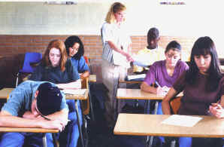

______________________________________________________________________________________

______________________________________________________________________________________

______________________________________________________________________________________

______________________________________________________________________________________

______________________________________________________________________________________

______________________________________________________________________________________

______________________________________________________________________________________

______________________________________________________________________________________

______________________________________________________________________________________

______________________________________________________________________________________

______________________________________________________________________________________

______________________________________________________________________________________

______________________________________________________________________________________

______________________________________________________________________________________

______________________________________________________________________________________

______________________________________________________________________________________

______________________________________________________________________________________

______________________________________________________________________________________

DÉCRIRE DES IMAGES; beskriv denna bild så utförligt som möjligt 15




































