DÉCRIRE ET RACONTER

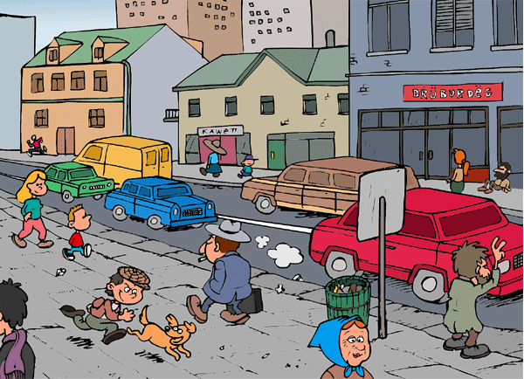

______________________________________________________________________________________

______________________________________________________________________________________

______________________________________________________________________________________

______________________________________________________________________________________

______________________________________________________________________________________

______________________________________________________________________________________

______________________________________________________________________________________

______________________________________________________________________________________

______________________________________________________________________________________

______________________________________________________________________________________

______________________________________________________________________________________

______________________________________________________________________________________

______________________________________________________________________________________

______________________________________________________________________________________

 | courir |  |  | marcher |  |  | attendre
je |  |  | je |  |  | je
tu |  |  | tu |  |  | tu
il |  |  | il |  |  | il
nous |  |  | nous |  |  | nous
vous |  |  | vous |  |  | vous
ils |  |  | ils |  |  | ils

