DÉCRIRE DES IMAGES 2

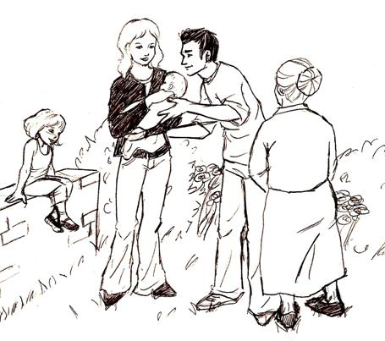

_________________________________________________________________________________________

_________________________________________________________________________________________

_________________________________________________________________________________________

_________________________________________________________________________________________

_________________________________________________________________________________________

_________________________________________________________________________________________

_________________________________________________________________________________________

_________________________________________________________________________________________

_________________________________________________________________________________________

_________________________________________________________________________________________

_________________________________________________________________________________________

_________________________________________________________________________________________
DÉCRIRE DES IMAGES 3

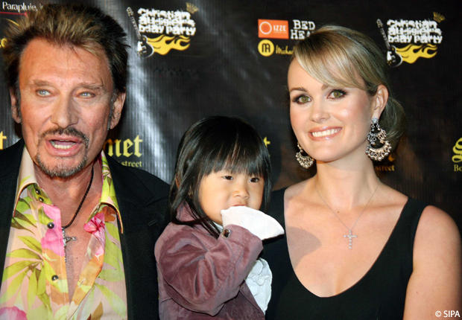

_________________________________________________________________________________________

_________________________________________________________________________________________

_________________________________________________________________________________________

_________________________________________________________________________________________

_________________________________________________________________________________________

_________________________________________________________________________________________

_________________________________________________________________________________________

_________________________________________________________________________________________

_________________________________________________________________________________________

_________________________________________________________________________________________

_________________________________________________________________________________________

_________________________________________________________________________________________

_________________________________________________________________________________________
DÉCRIRE DES IMAGES 4




























