http://www.estudiodefrances.com/tbi/icipassecompose.html

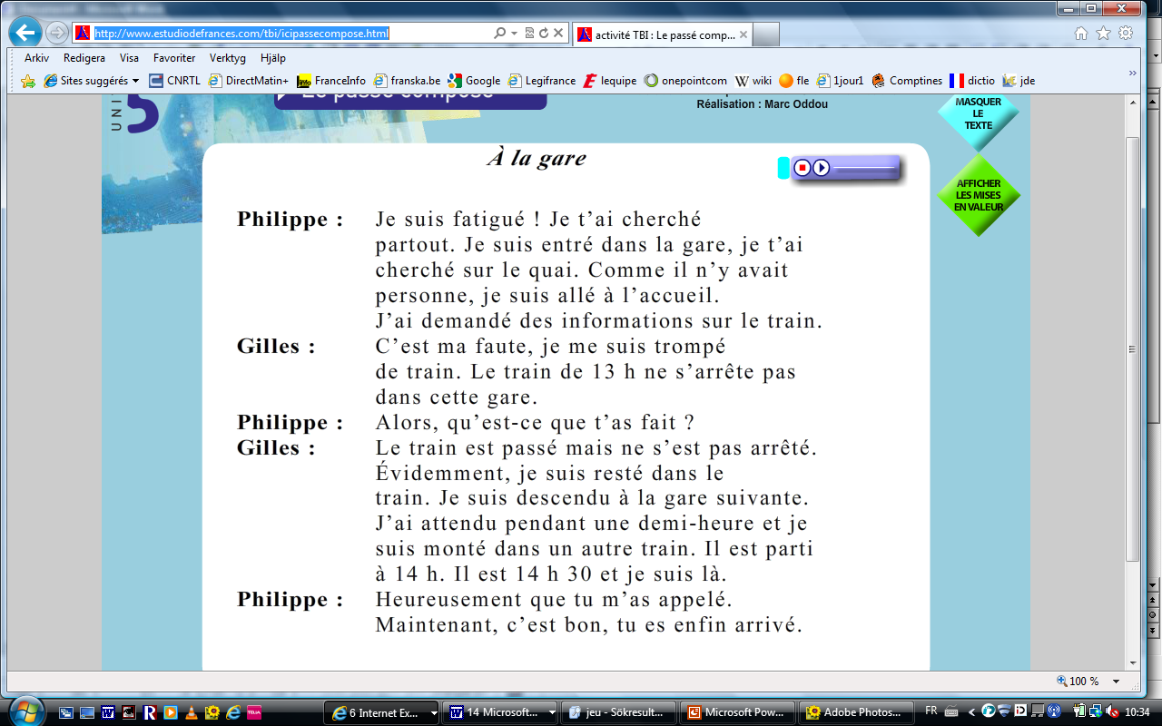

<!DOCTYPE html PUBLIC "-//W3C//DTD XHTML 1.0 Transitional//EN" "http://www.w3.org/TR/xhtml1/DTD/xhtml1-transitional.dtd">
<html xmlns="http://www.w3.org/1999/xhtml">
<head>
<meta http-equiv="Content-Type" content="text/html; charset=UTF-8" />
<title>activité TBI : Le passé composé</title>
<script src="../Scripts/AC_RunActiveContent.js" type="text/javascript"></script>
<style type="text/css">
<!--
body {
background-color: #CCCCCC;
}
-->
</style></head>

<body>
<table width="200" border="0" align="center">
<tr>
<td><script type="text/javascript">
AC_FL_RunContent( 'codebase','http://download.macromedia.com/pub/shockwave/cabs/flash/swflash.cab#version=9,0,28,0','width','1024','height','768','src','extraiticipasse','quality','high','pluginspage','http://www.adobe.com/shockwave/download/download.cgi?P1_Prod_Version=ShockwaveFlash','movie','extraiticipasse' ); //end AC code
</script><noscript><object classid="clsid:D27CDB6E-AE6D-11cf-96B8-444553540000" codebase="http://download.macromedia.com/pub/shockwave/cabs/flash/swflash.cab#version=9,0,28,0" width="1024" height="768">
<param name="movie" value="extraiticipasse.swf" />
<param name="quality" value="high" />
<embed src="extraiticipasse.swf" quality="high" pluginspage="http://www.adobe.com/shockwave/download/download.cgi?P1_Prod_Version=ShockwaveFlash" type="application/x-shockwave-flash" width="1024" height="768"></embed>
</object></noscript></td>
</tr>
<tr>
<td><div align="center"><a href="http://www.estudiodefrances.com">Accueil / Inicio</a></div></td>
</tr>
</table>
</body>
</html>

extraiticipasse.swf

http://www.estudiodefrances.com/tbi/extraiticipasse.swf

