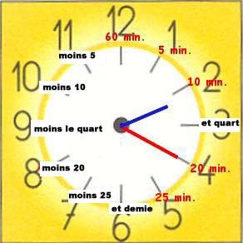
säg nu följande klockslag:

14.20__________________________________________________________________________

16.10__________________________________________________________________________

15.25__________________________________________________________________________

14.50__________________________________________________________________________

17.55__________________________________________________________________________

18.40__________________________________________________________________________

20.45__________________________________________________________________________

22.15__________________________________________________________________________

19.35__________________________________________________________________________

16.05__________________________________________________________________________

