DÉCRIRE DES IMAGES 2

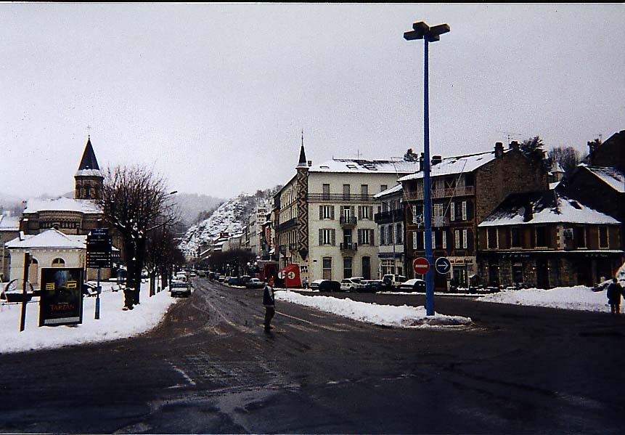

Faites une rédaction à partir de cette image. Quelques questions pour vous aider : Qui traverse la rue ? Comment s’appelle cette personne ? Son âge? Sa profession? Où va-t-elle? Où sommes-nous? Quel temps fait-il?

_____________________________________________________________________________________

_____________________________________________________________________________________

_____________________________________________________________________________________

_____________________________________________________________________________________

_____________________________________________________________________________________

_____________________________________________________________________________________

_____________________________________________________________________________________

_____________________________________________________________________________________

_____________________________________________________________________________________

_____________________________________________________________________________________

_____________________________________________________________________________________

_____________________________________________________________________________________

_____________________________________________________________________________________

_____________________________________________________________________________________

_____________________________________________________________________________________

_____________________________________________________________________________________

_____________________________________________________________________________________

_____________________________________________________________________________________

_____________________________________________________________________________________