DÉCRIRE DES IMAGES 1

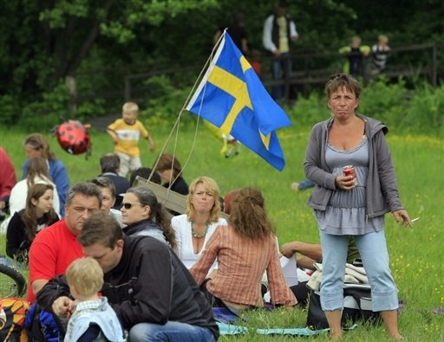

______________________________________________________________________________________

______________________________________________________________________________________

______________________________________________________________________________________

______________________________________________________________________________________

______________________________________________________________________________________

______________________________________________________________________________________

______________________________________________________________________________________

______________________________________________________________________________________

______________________________________________________________________________________

______________________________________________________________________________________

______________________________________________________________________________________

______________________________________________________________________________________

______________________________________________________________________________________

DÉCRIRE DES IMAGES 2



































