DECRIRE DES IMAGES 1

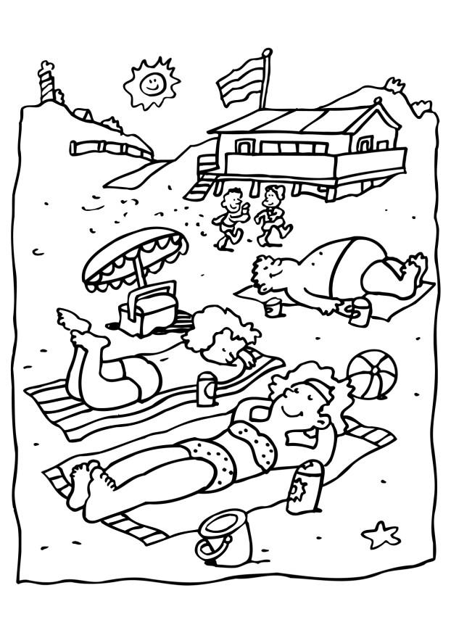
______________________________________________________________________________________

______________________________________________________________________________________

______________________________________________________________________________________

______________________________________________________________________________________

______________________________________________________________________________________

______________________________________________________________________________________

______________________________________________________________________________________

______________________________________________________________________________________
DECRIRE DES IMAGES 2

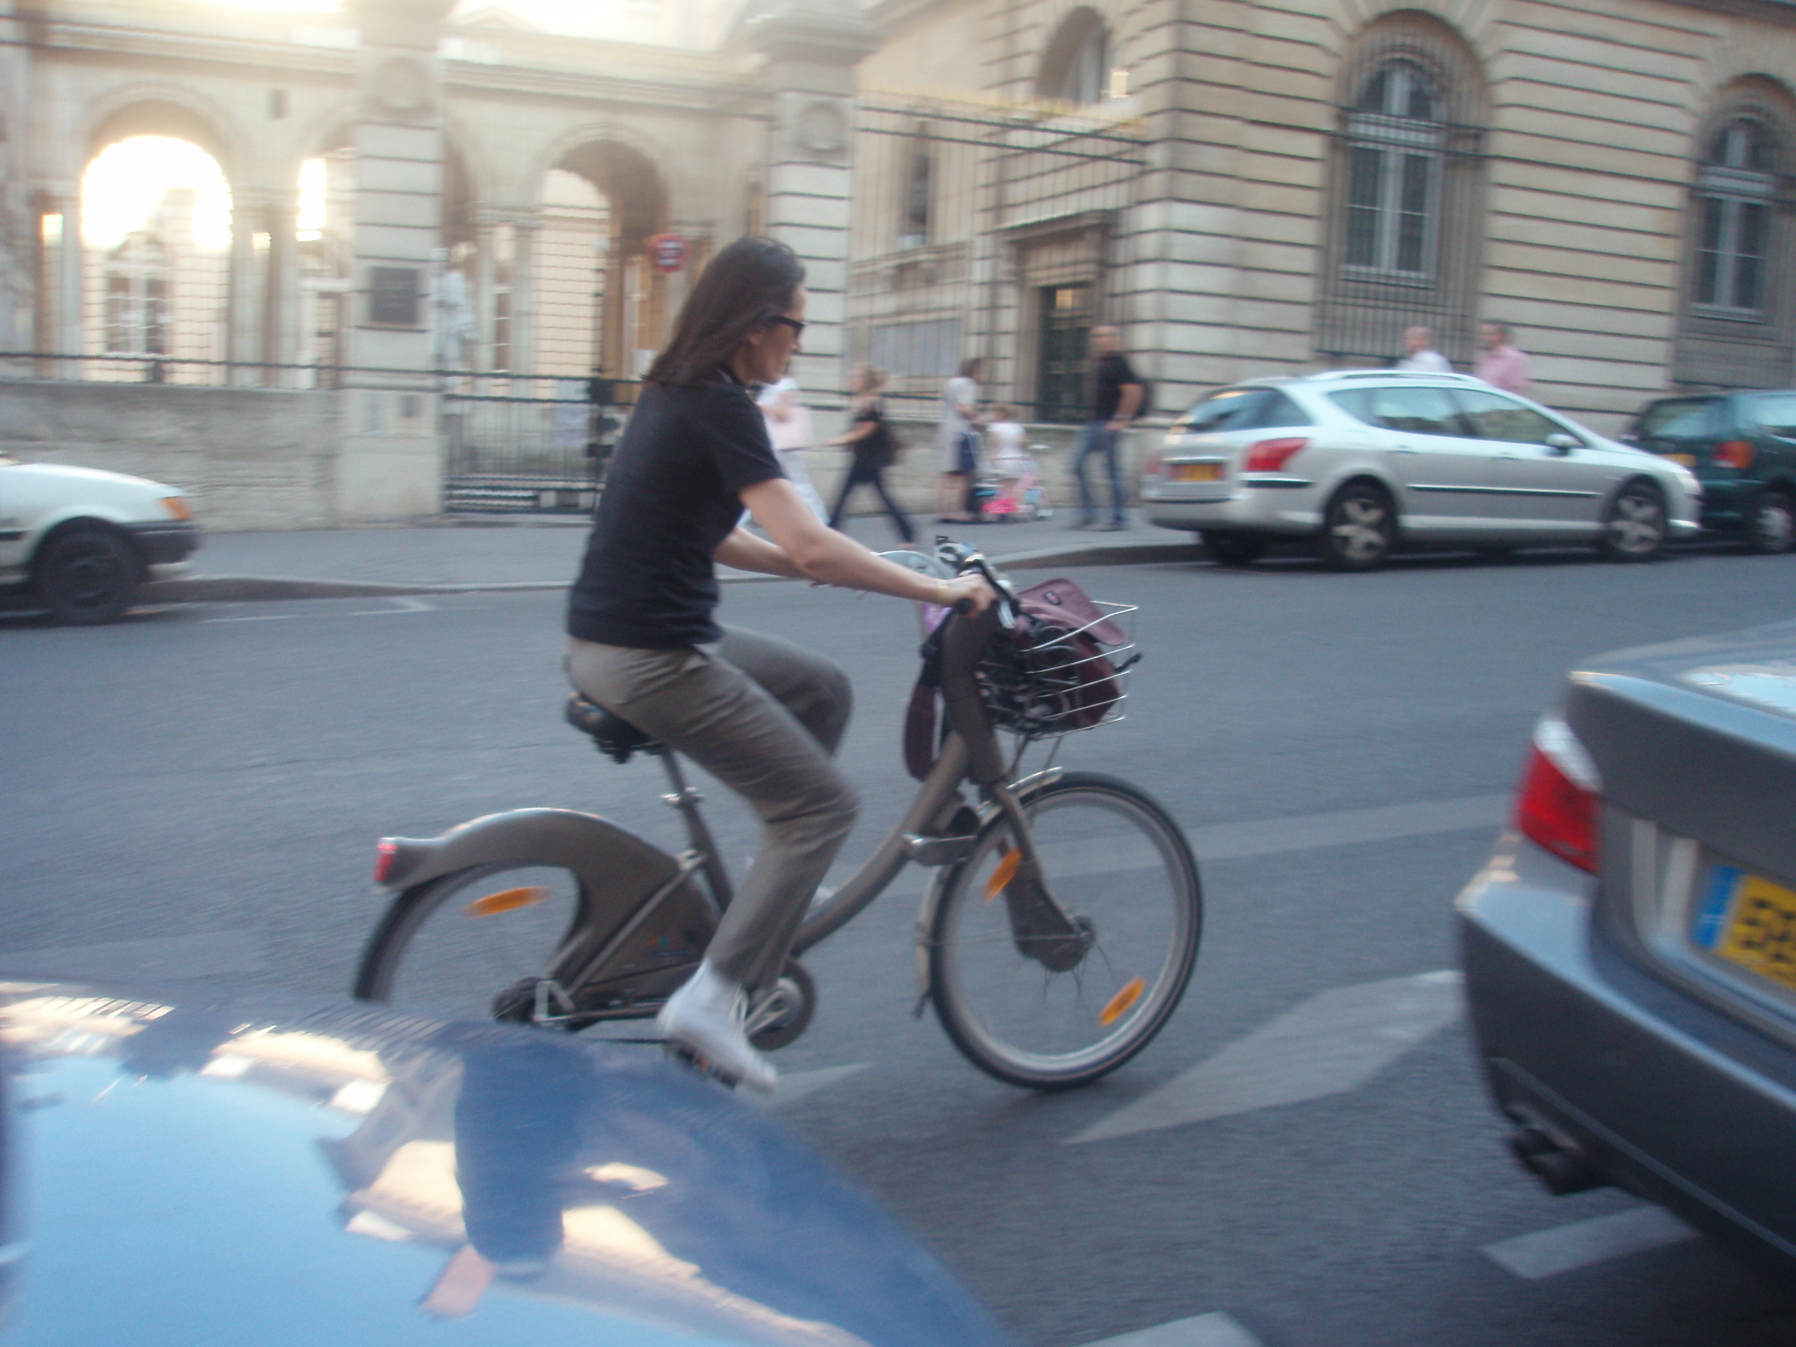

______________________________________________________________________________________

______________________________________________________________________________________

______________________________________________________________________________________

______________________________________________________________________________________

______________________________________________________________________________________

______________________________________________________________________________________

______________________________________________________________________________________

______________________________________________________________________________________

______________________________________________________________________________________

______________________________________________________________________________________

______________________________________________________________________________________

______________________________________________________________________________________

______________________________________________________________________________________

______________________________________________________________________________________
DECRIRE DES IMAGES 3; beskriv bilden på franska































