DESCRIPTION DES IMAGES 1

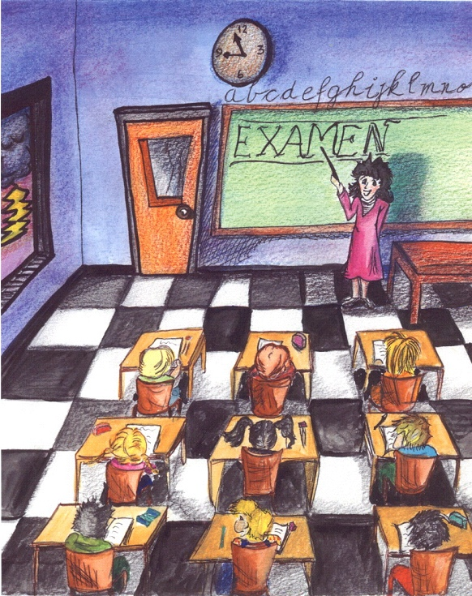

_________________________________________________________________________________________________________________________________

_________________________________________________________________________________________________________________________________

_________________________________________________________________________________________________________________________________

_________________________________________________________________________________________________________________________________

_________________________________________________________________________________________________________________________________

_________________________________________________________________________________________________________________________________
DESCRIPTION DES IMAGES 2














