décrire des images 10; qui sont-ils ? où sont-ils ? pourquoi sont-ils là ? de quoi parlent-ils ? ils ont quel âge ? etc
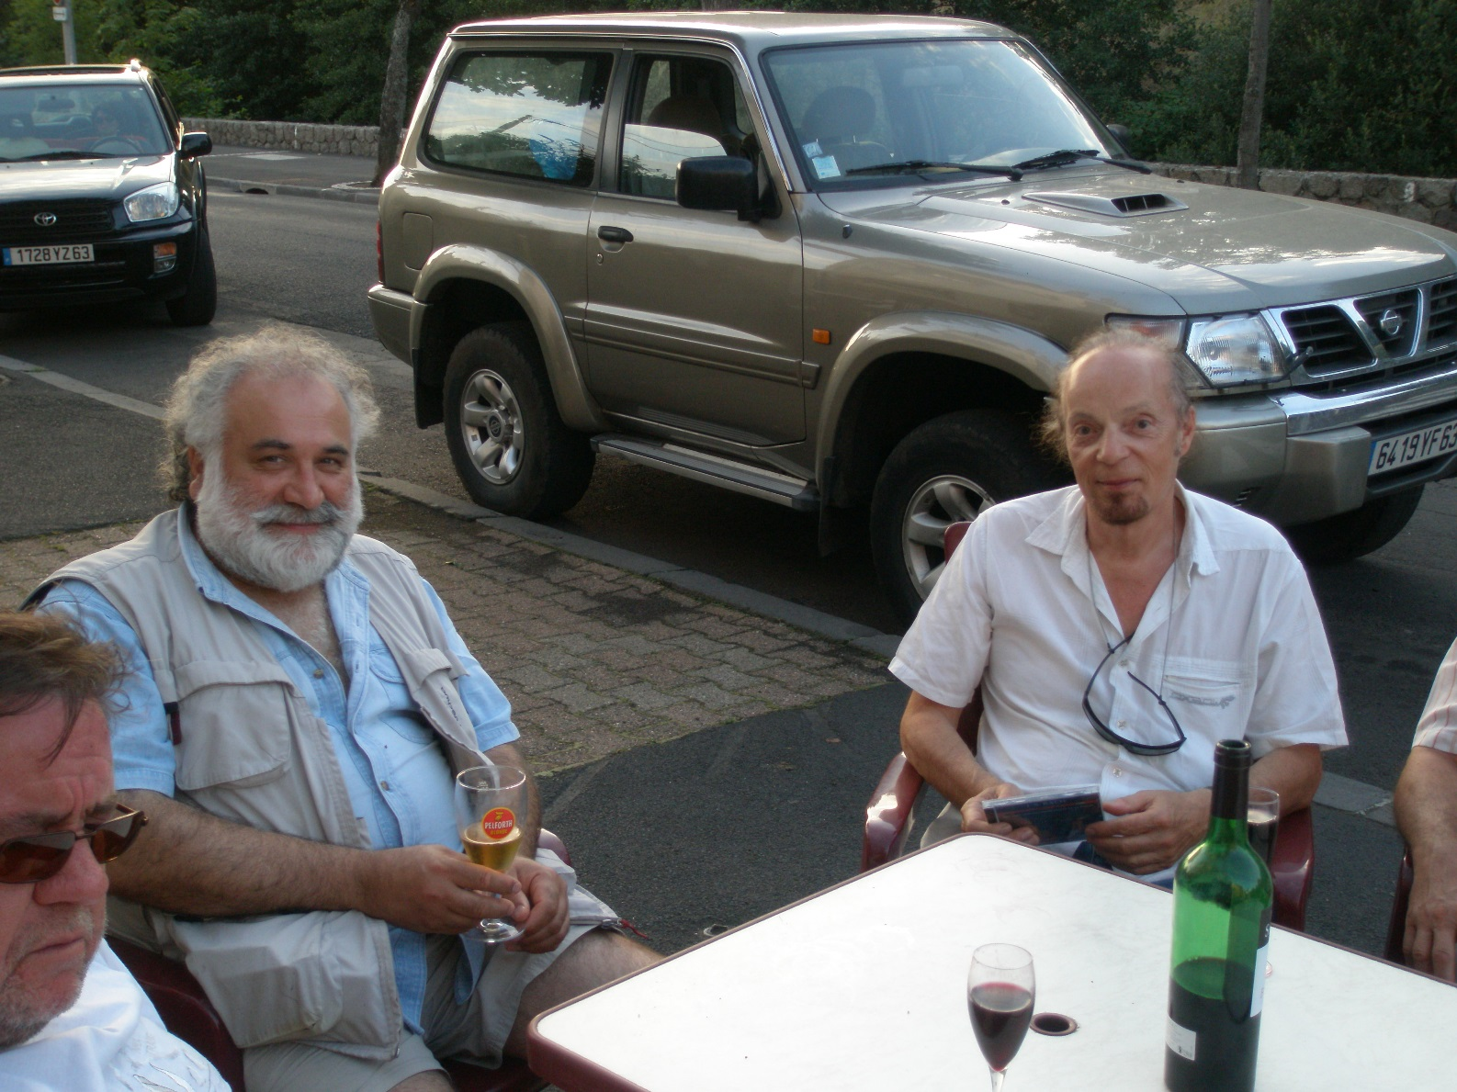
______________________________________________________________________________________________
______________________________________________________________________________________________
______________________________________________________________________________________________
______________________________________________________________________________________________
______________________________________________________________________________________________
______________________________________________________________________________________________
______________________________________________________________________________________________
______________________________________________________________________________________________
______________________________________________________________________________________________
______________________________________________________________________________________________
______________________________________________________________________________________________
______________________________________________________________________________________________
______________________________________________________________________________________________
______________________________________________________________________________________________
______________________________________________________________________________________________
______________________________________________________________________________________________
______________________________________________________________________________________________
décrire des images 11; décrivez cette photo, qu’est-ce que c’est ? qu’est-ce qu’il y a dedans ? ça se trouve où ? etc
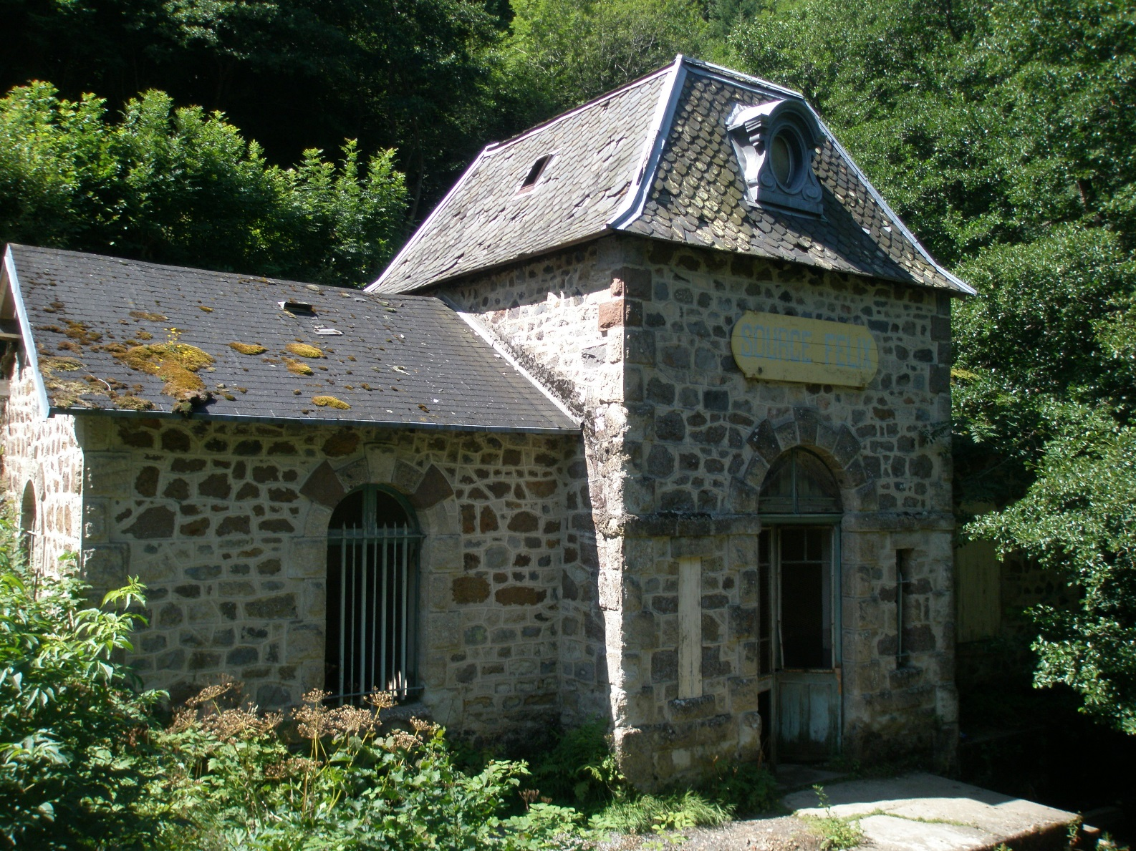
______________________________________________________________________________________________
______________________________________________________________________________________________
______________________________________________________________________________________________
______________________________________________________________________________________________
______________________________________________________________________________________________
______________________________________________________________________________________________
______________________________________________________________________________________________
______________________________________________________________________________________________
______________________________________________________________________________________________
______________________________________________________________________________________________
______________________________________________________________________________________________
______________________________________________________________________________________________
______________________________________________________________________________________________
______________________________________________________________________________________________
______________________________________________________________________________________________
______________________________________________________________________________________________
______________________________________________________________________________________________
décrire des images 12; qui sont-ils ? où sont-ils ? pourquoi sont-ils là ? de quoi parlent-ils ? ils ont quel âge ? etc
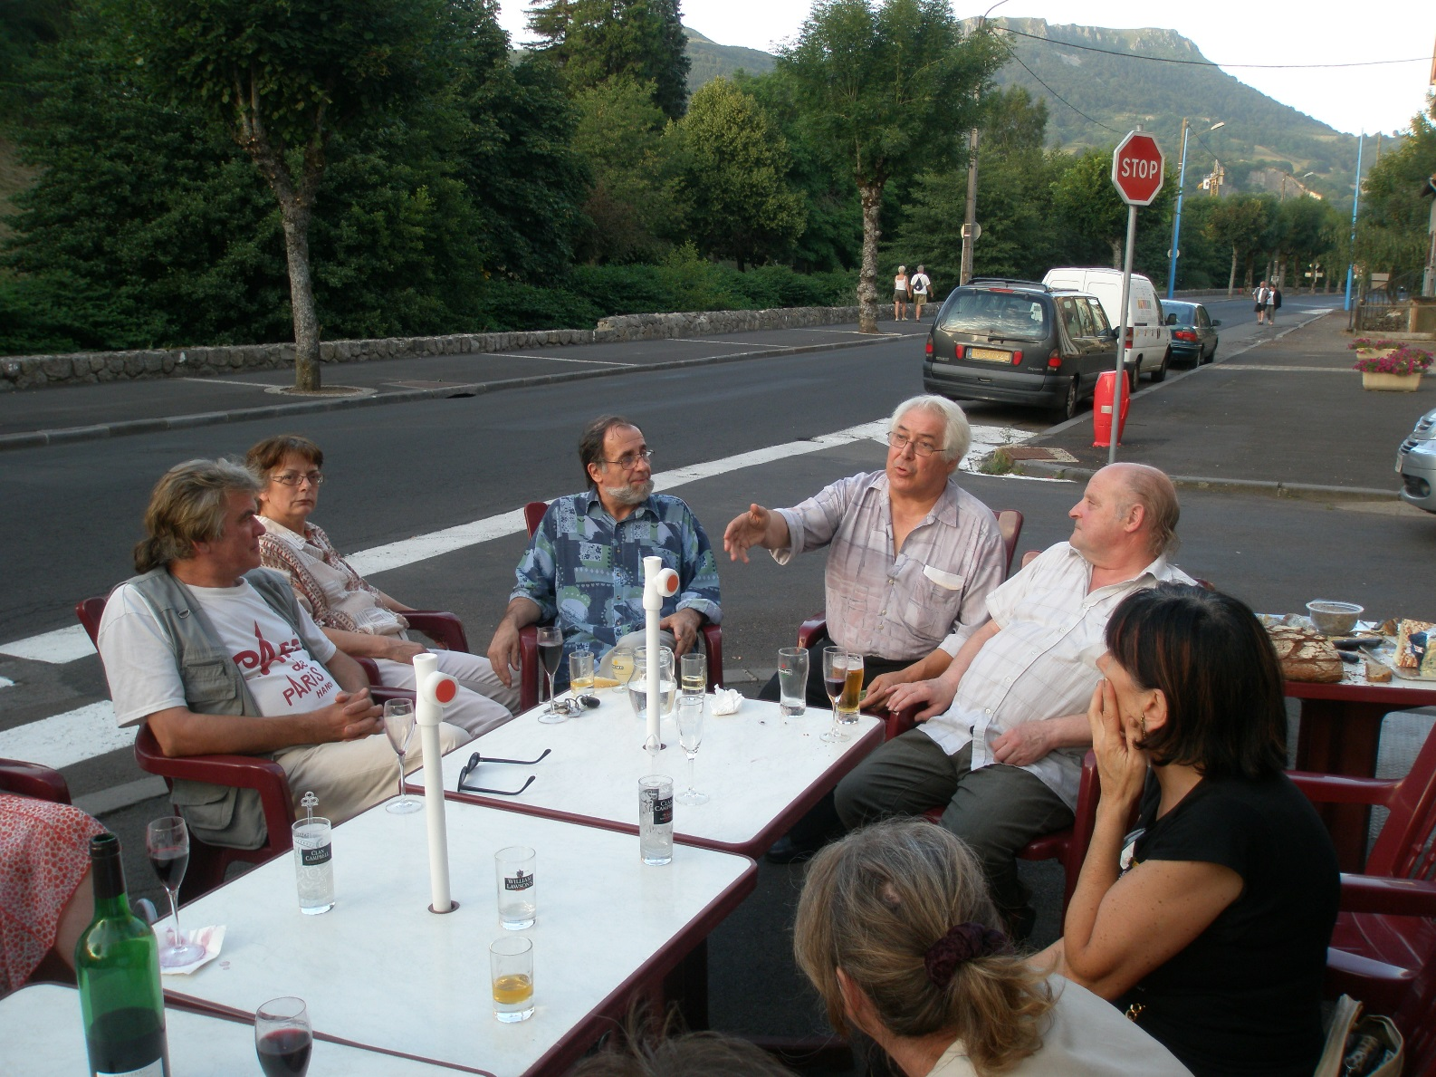
______________________________________________________________________________________________
______________________________________________________________________________________________
______________________________________________________________________________________________
______________________________________________________________________________________________
______________________________________________________________________________________________
______________________________________________________________________________________________
______________________________________________________________________________________________
______________________________________________________________________________________________
______________________________________________________________________________________________
______________________________________________________________________________________________
______________________________________________________________________________________________
______________________________________________________________________________________________
______________________________________________________________________________________________
______________________________________________________________________________________________
______________________________________________________________________________________________
______________________________________________________________________________________________
______________________________________________________________________________________________
décrire des images 13; qui est-ce ? qu’est-ce qu’il regarde ? que fait-il là ? qu’est-ce qu’il va faire ?
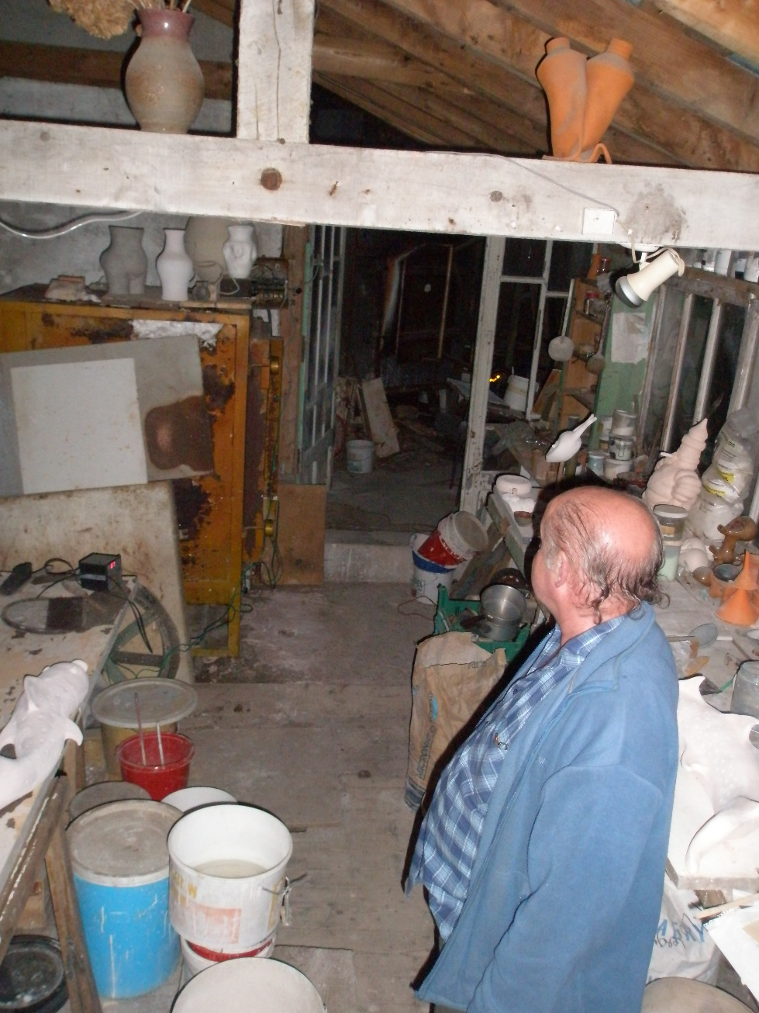
______________________________________________________________________________________________
______________________________________________________________________________________________
______________________________________________________________________________________________
______________________________________________________________________________________________
______________________________________________________________________________________________
______________________________________________________________________________________________
______________________________________________________________________________________________
______________________________________________________________________________________________
______________________________________________________________________________________________
______________________________________________________________________________________________
______________________________________________________________________________________________
______________________________________________________________________________________________
______________________________________________________________________________________________
______________________________________________________________________________________________
______________________________________________________________________________________________
décrire des images 14; qui sont-ils ? où sont-ils ? pourquoi sont-ils là ? comment s’appellent-ils ? etc


















