DÉCRIRE DES IMAGES 1

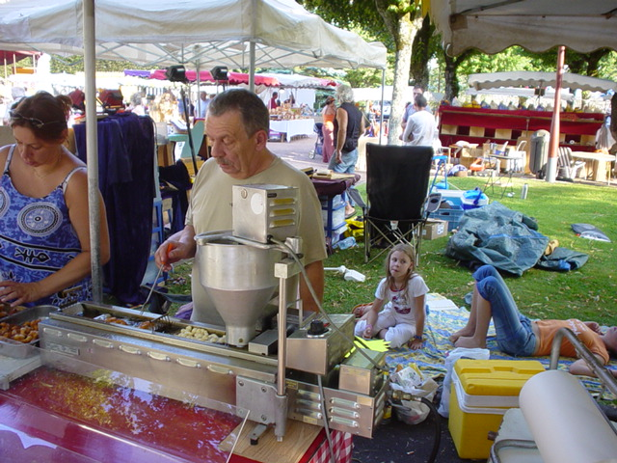

______________________________________________________________________________________

______________________________________________________________________________________

______________________________________________________________________________________

______________________________________________________________________________________

______________________________________________________________________________________

______________________________________________________________________________________

______________________________________________________________________________________

______________________________________________________________________________________

______________________________________________________________________________________

______________________________________________________________________________________

______________________________________________________________________________________

______________________________________________________________________________________

______________________________________________________________________________________

______________________________________________________________________________________
DÉCRIRE DES IMAGES 2

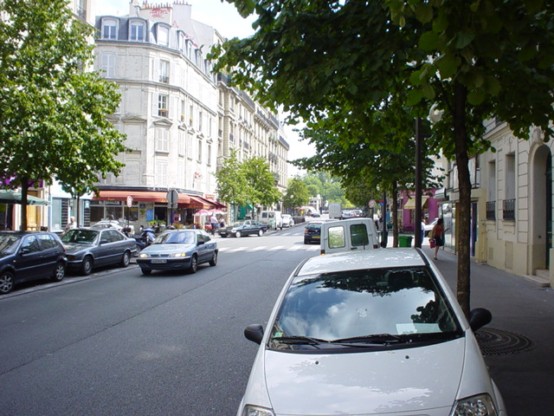

______________________________________________________________________________________

______________________________________________________________________________________

______________________________________________________________________________________

______________________________________________________________________________________

______________________________________________________________________________________

______________________________________________________________________________________

______________________________________________________________________________________

______________________________________________________________________________________

______________________________________________________________________________________

______________________________________________________________________________________

______________________________________________________________________________________

______________________________________________________________________________________

______________________________________________________________________________________

______________________________________________________________________________________
DÉCRIRE DES IMAGES 3

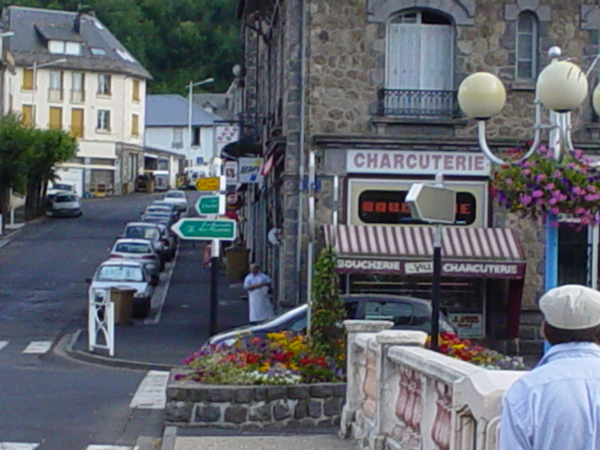

______________________________________________________________________________________

______________________________________________________________________________________

______________________________________________________________________________________

______________________________________________________________________________________

______________________________________________________________________________________

______________________________________________________________________________________

______________________________________________________________________________________

______________________________________________________________________________________

______________________________________________________________________________________

______________________________________________________________________________________

______________________________________________________________________________________

______________________________________________________________________________________

______________________________________________________________________________________

______________________________________________________________________________________
DÉCRIRE DES IMAGES 4

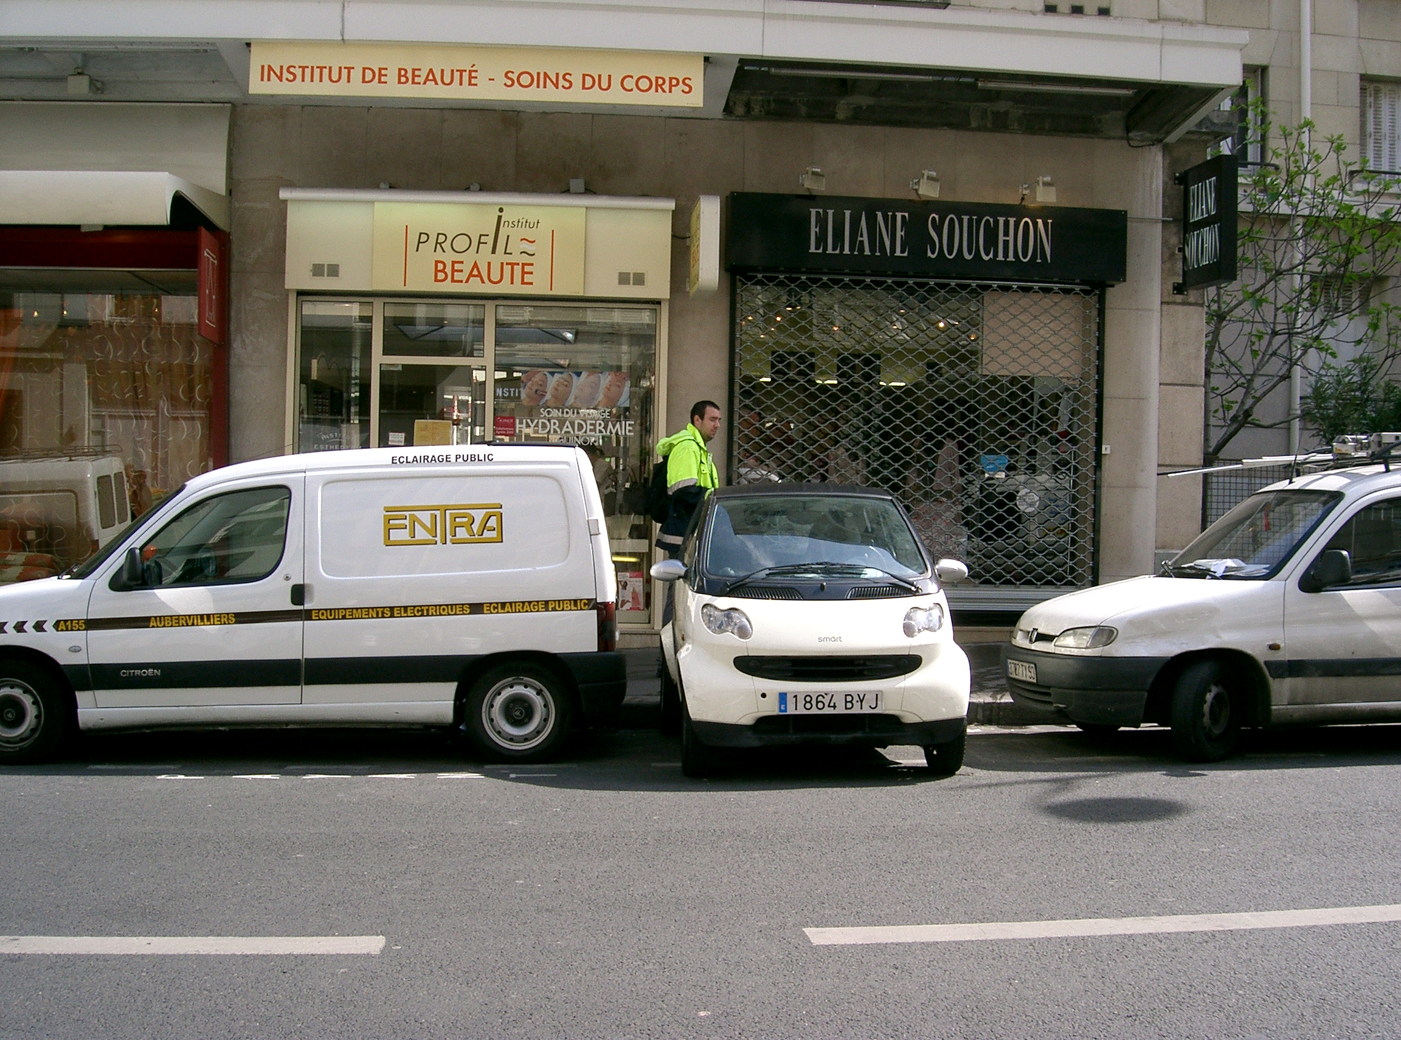

______________________________________________________________________________________

______________________________________________________________________________________

______________________________________________________________________________________

______________________________________________________________________________________

______________________________________________________________________________________

______________________________________________________________________________________

______________________________________________________________________________________

______________________________________________________________________________________

______________________________________________________________________________________

______________________________________________________________________________________

______________________________________________________________________________________

______________________________________________________________________________________

______________________________________________________________________________________

______________________________________________________________________________________
DÉCRIRE DES IMAGES 5

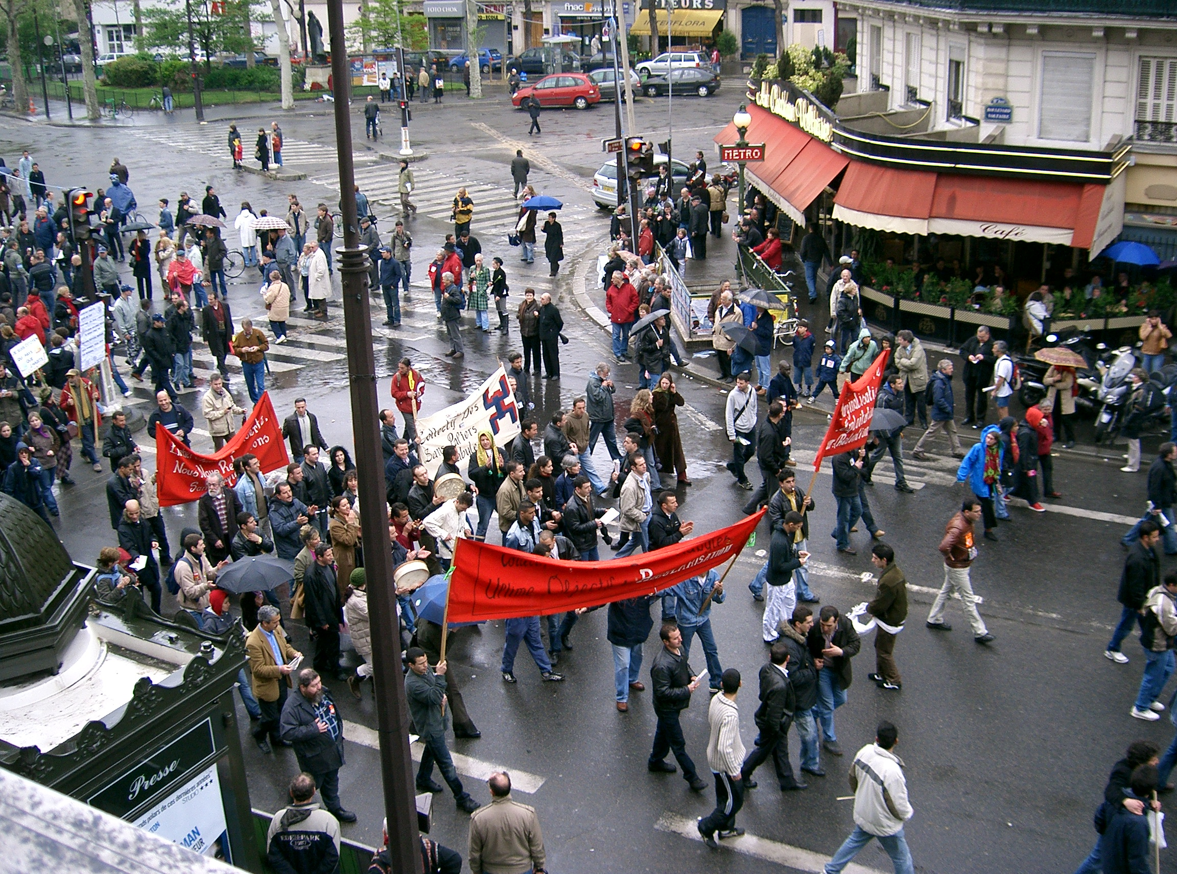

______________________________________________________________________________________

______________________________________________________________________________________

______________________________________________________________________________________

______________________________________________________________________________________

______________________________________________________________________________________

______________________________________________________________________________________

______________________________________________________________________________________

______________________________________________________________________________________

______________________________________________________________________________________

______________________________________________________________________________________

______________________________________________________________________________________

______________________________________________________________________________________

______________________________________________________________________________________

______________________________________________________________________________________
DÉCRIRE DES IMAGES 6

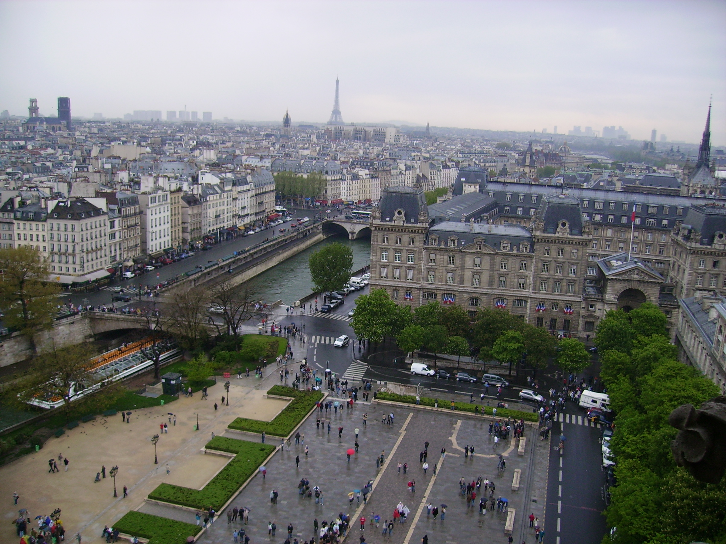

______________________________________________________________________________________

______________________________________________________________________________________

______________________________________________________________________________________

______________________________________________________________________________________

______________________________________________________________________________________

______________________________________________________________________________________

______________________________________________________________________________________

______________________________________________________________________________________

______________________________________________________________________________________

______________________________________________________________________________________

______________________________________________________________________________________

______________________________________________________________________________________

______________________________________________________________________________________

______________________________________________________________________________________
DÉCRIRE DES IMAGES 7

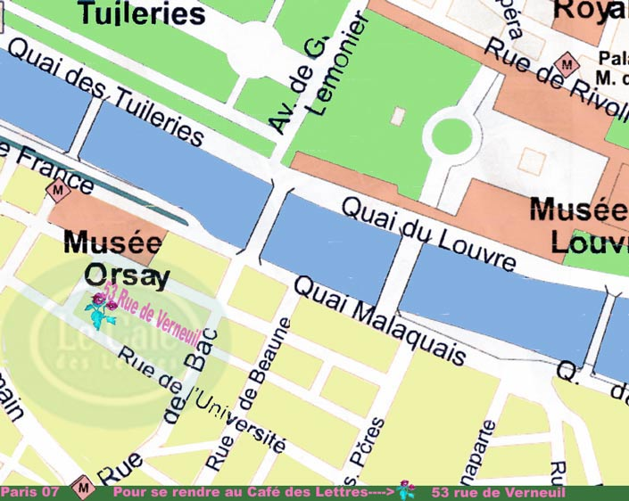

______________________________________________________________________________________

______________________________________________________________________________________

______________________________________________________________________________________

______________________________________________________________________________________

______________________________________________________________________________________

______________________________________________________________________________________

______________________________________________________________________________________

______________________________________________________________________________________

______________________________________________________________________________________

______________________________________________________________________________________

______________________________________________________________________________________

______________________________________________________________________________________

______________________________________________________________________________________

DÉCRIRE DES IMAGES 8

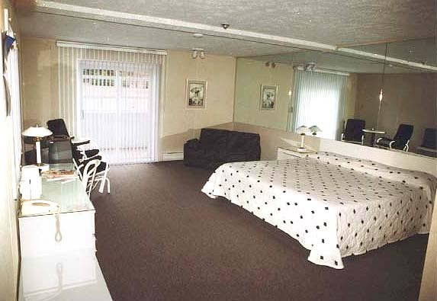

______________________________________________________________________________________

______________________________________________________________________________________

______________________________________________________________________________________

______________________________________________________________________________________

______________________________________________________________________________________

______________________________________________________________________________________

______________________________________________________________________________________

______________________________________________________________________________________

______________________________________________________________________________________

______________________________________________________________________________________

______________________________________________________________________________________

______________________________________________________________________________________

______________________________________________________________________________________

______________________________________________________________________________________

DÉCRIRE DES IMAGES 9





















