

|  |  |  |  |  |  |  |  |  |
| --- | --- | --- | --- | --- | --- | --- | --- | --- |
|  |  |  |  |  |  |  |  |  |
| J | R | E | A | I | R | N | D | I |

|  |  |  |  |  |  |  |  |  |
| --- | --- | --- | --- | --- | --- | --- | --- | --- |
| J | A | R | D | I | N | I | E | R |



|  |  |  |  |  |  |  |
| --- | --- | --- | --- | --- | --- | --- |
| P | R | E | T | I | N | E |
|  |  |  |  |  |  |  |
| P | E | I | N | T | R | E |



|  |  |  |  |  |  |  |  |  |  |  |
| --- | --- | --- | --- | --- | --- | --- | --- | --- | --- | --- |
| N | E | E | L | I | E | C | C | I | T | R |
|  |  |  |  |  |  |  |  |  |  |  |
| E | L | E | C | T | R | I | C | I | E | N |



|  |  |  |  |  |  |  |  |  |
| --- | --- | --- | --- | --- | --- | --- | --- | --- |
| M | I | S | U | I | E | E | N | R |
|  |  |  |  |  |  |  |  |  |
| M | E | N | U | I | S | I | E | R |



|  |  |  |  |  |
| --- | --- | --- | --- | --- |
| T | A | G | N | E |
|  |  |  |  |  |
| A | G | E | N | T |



|  |  |  |  |  |
| --- | --- | --- | --- | --- |
| O | M | Ç | A | N |
|  |  |  |  |  |
| M | A | Ç | O | N |

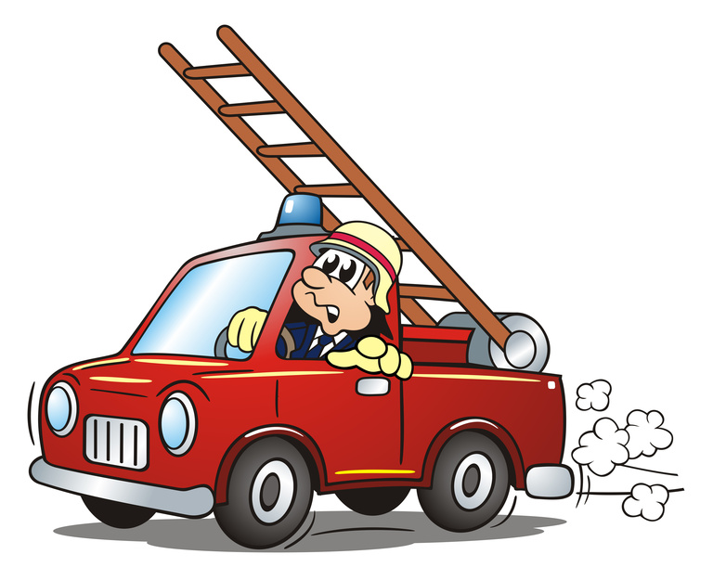

|  |  |  |  |  |  |  |
| --- | --- | --- | --- | --- | --- | --- |
| E | P | I | M | R | P | O |
|  |  |  |  |  |  |  |
| P | O | M | P | I | E | R |



|  |  |  |  |  |  |  |  |  |
| --- | --- | --- | --- | --- | --- | --- | --- | --- |
| G | E | A | T | R | S | A | I | G |
|  |  |  |  |  |  |  |  |  |
| G | A | R | A | G | I | S | T | E |



|  |  |  |  |  |  |  |  |
| --- | --- | --- | --- | --- | --- | --- | --- |
| P | E | R | L | I | O | B | M |
|  |  |  |  |  |  |  |  |
| P | L | O | M | B | I | E | R |



|  |  |  |  |  |  |  |
| --- | --- | --- | --- | --- | --- | --- |
| B | R | E | O | H | U | C |
|  |  |  |  |  |  |  |
| B | O | U | C | H | E | R |



|  |  |  |  |  |  |  |  |  |
| --- | --- | --- | --- | --- | --- | --- | --- | --- |
| A | E | B | N | G | O | R | U | L |

|  |  |  |  |  |  |  |  |  |
| --- | --- | --- | --- | --- | --- | --- | --- | --- |
|  |  |  |  |  |  |  |  |  |
| B | O | U | L | A | N | G | E | R |



|  |  |  |  |  |  |  |
| --- | --- | --- | --- | --- | --- | --- |
| F | C | E | U | A | T | R |
|  |  |  |  |  |  |  |
| F | A | C | T | E | U | R |

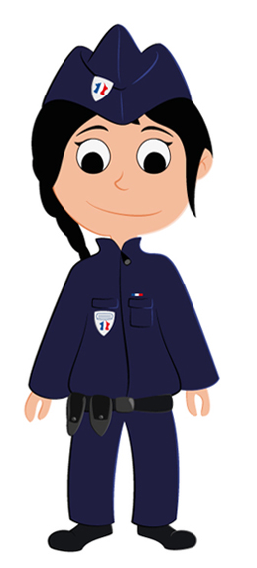

|  |  |  |  |  |  |  |  |
| --- | --- | --- | --- | --- | --- | --- | --- |
| P | E | I | R | C | O | L | I |
|  |  |  |  |  |  |  |  |
| P | O | L | I | C | I | E | R |



|  |  |  |  |  |  |  |
| --- | --- | --- | --- | --- | --- | --- |
| D | U | R | E | O | T | C |
|  |  |  |  |  |  |  |
| D | O | C | T | E | U | R |



|  |  |  |  |  |  |  |  |  |
| --- | --- | --- | --- | --- | --- | --- | --- | --- |
| C | U | I | S | I | N | I | E | R |
|  |  |  |  |  |  |  |  |  |

|  |  |  |  |  |  |  |  |  |
| --- | --- | --- | --- | --- | --- | --- | --- | --- |
| C | R | E | U | I | I | S | N | I |