8547RÉDACTION 1 – beskriv bilden

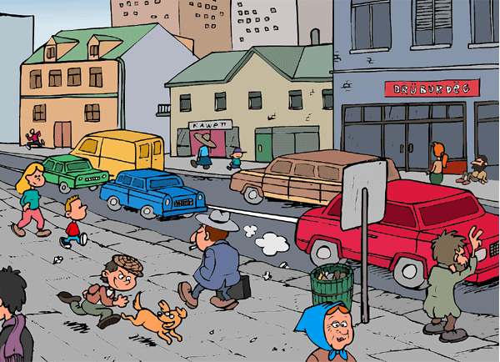

______________________________________________________________________________________

______________________________________________________________________________________

______________________________________________________________________________________

______________________________________________________________________________________

______________________________________________________________________________________

______________________________________________________________________________________

______________________________________________________________________________________

______________________________________________________________________________________

______________________________________________________________________________________

______________________________________________________________________________________

______________________________________________________________________________________

______________________________________________________________________________________

______________________________________________________________________________________

______________________________________________________________________________________

______________________________________________________________________________________
ÉCRIRE ET CONSTRUIRE DES PHRASES

översätt till franska; bilda sedan fullständiga meningar med orden, du kan ändra formen på orden, t.ex. springa kan bli ”jag springer”

städa | diska | shoppa
spela basket | göra dumheter | stå i kö
laga mat | köpa | betala
presenter | springa – jag springer | att gå – jag går
handla | gråta | läsa

______________________________________________________________________________________

______________________________________________________________________________________

______________________________________________________________________________________

______________________________________________________________________________________

______________________________________________________________________________________

______________________________________________________________________________________

______________________________________________________________________________________

______________________________________________________________________________________

______________________________________________________________________________________

______________________________________________________________________________________

______________________________________________________________________________________

______________________________________________________________________________________

______________________________________________________________________________________

______________________________________________________________________________________

______________________________________________________________________________________

______________________________________________________________________________________

______________________________________________________________________________________

______________________________________________________________________________________

______________________________________________________________________________________

______________________________________________________________________________________

