[fiche débutants](http://www.franska.be/exercicesdujour/pizzaloulou/fichesdebutant.docx) 1; [site pour débutants](http://nivelbasico1.wikispaces.com/)

c’est quelle couleur? c’est rouge

|  |  |  |
| --- | --- | --- |
| röd= | svart= | vit= |
| blå= | grå= | gul= |
| grön= | rosa= | brun= |
| lila= | turkos= | ljusgrön= |
| mörkgrön= | en färg= |  |

Fråga och svara nu om följande färger:

|  |  |  |  |  |  |  |  |  |  |
| --- | --- | --- | --- | --- | --- | --- | --- | --- | --- |
|  |  |  |  |  |  |  |  |  |  |
|  |  |  |  |  |  |  |  |  |  |
|  |  |  |  |  |  |  |  |  |  |
|  |  |  |  |  |  |  |  |  |  |

|  |  |
| --- | --- |
| quelle est ta couleur préférée? | ma couleur préférée c’est le bleu |
|  |  |
| tu aimes le rose? | oui, j’aime le rose |
|  |  |
| tu aimes le jaune? | non, je n’aime pas le jaune |
|  |  |
| tu détestes le marron? | oui, je déteste le marron |
|  |  |
| quelle est la couleur de ton vélo? | il est vert |
|  |  |

Ställ frågor till varandra enligt ovanstående modell; se till att du förstår meningarna ordentligt först och träna uttalet!

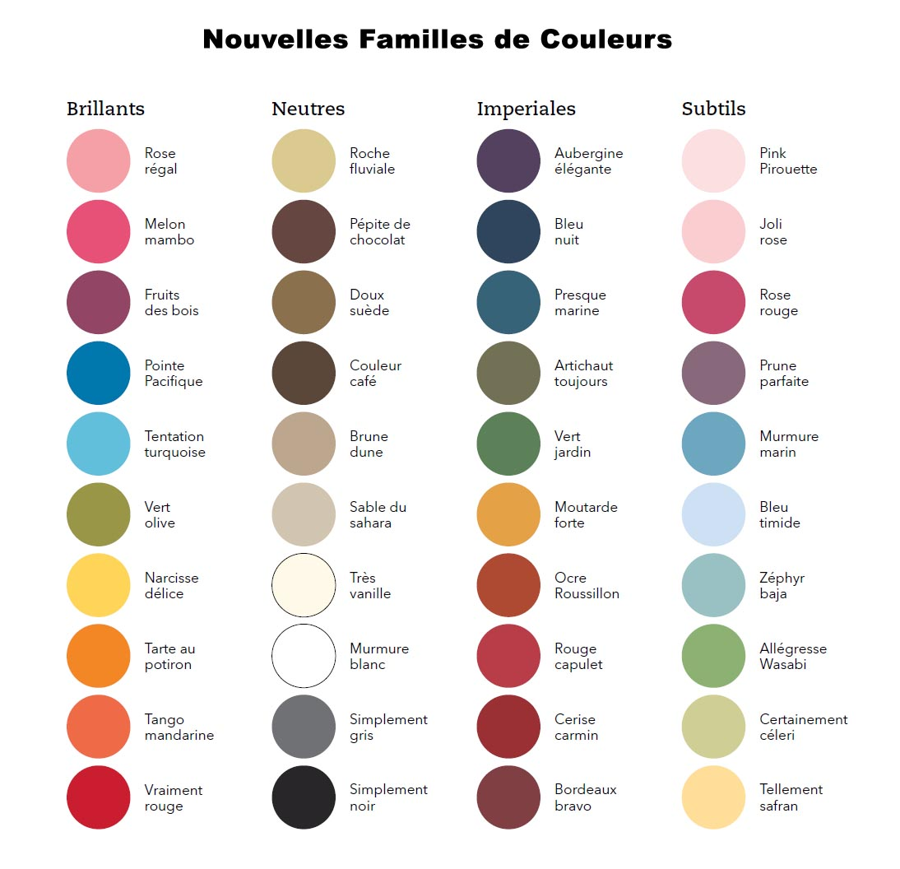

1fichealphabet

Lyssna och läs alfabetet på franska:

|  |  |  |  |  |  |  |  |  |  |  |  |  |
| --- | --- | --- | --- | --- | --- | --- | --- | --- | --- | --- | --- | --- |
| a | b | c | d | e | f | g | h | i | j | k | l | m |
|  |  |  |  |  |  |  |  |  |  |  |  |  |
| n | o | p | q | r | s | t | u | v | w | x | y | z |
|  |  |  |  |  |  |  |  |  |  |  |  |  |

|  |  |  |  |
| --- | --- | --- | --- |
| é | è | ê | î |
| e accent aigu | a accent grave | e accent circonflexe | i tréma |
| ç | å | ä | ö |
| c cédille | a avec un petit rond | a tréma | o tréma |

Läs bilskyltarna för varandra:

|  |  |  |
| --- | --- | --- |
|  |  |  |
|  |  |  |
|  |  |  |

épelez, s’il vous plaît

ça s’écrit comment?

vous pouvez épeler?

tu peux épeler?

Läs nu och be kompisen bokstavera olika ord/använd ordlista/leta ord på internet som du bokstaverar för kompisen; kompisen som lyssnar skriver upp det han/hon förstår

|  |  |  |  |  |
| --- | --- | --- | --- | --- |
| Cécile | Jean | Yannick | Camille | Alain |
| Muffat | Loeb | Cahuzac | Jérôme | François |
| Vincent | Peillon | Sarkozy | Ségolène | Royal |
| Valls | Taubira | Lavilenie | Romain | Grosjean |
| Jacques | Goldman | Oyonnax | Étienne | Brigitte Bardot |
| Gérard Depardieu | Yvette Guilbert | Édith Gassion | Charles Pic | Jérémy Stravius |

|  |  |  |  |  |  |  |  |  |  |  |
| --- | --- | --- | --- | --- | --- | --- | --- | --- | --- | --- |
| c’est quel jour? | |  | | | | c’est....... | |  | | |
| måndag |  | | tisdag |  | onsdag | |  | | torsdag |  |
| fredag |  | | lördag |  | söndag | |  | | datum |  |

|  |  |  |  |  |  |  |  |  |  |  |  |  |
| --- | --- | --- | --- | --- | --- | --- | --- | --- | --- | --- | --- | --- |
| c’est quel numéro? | | |  | | | | c’est........ | | |  | | |
| 3 | 6 | 9 | | 1 | 7 | 4 | | 8 | 5 | | 2 | 10 |
|  |  |  | |  |  |  | |  |  | |  |  |
| 17 | 11 | 18 | | 12 | 19 | 13 | | 16 | 14 | | 20 | 15 |
|  |  |  | |  |  |  | |  |  | |  |  |
| 20 | 70 | 10 | | 60 | 30 | 80 | | 90 | 40 | | 100 | 50 |
|  |  |  | |  |  |  | |  |  | |  |  |

|  |  |  |  |  |  |  |  |  |  |
| --- | --- | --- | --- | --- | --- | --- | --- | --- | --- |
| **15** | **17** | **25** | **10** | **38** | **80** | **100** | **5** | **0** | **87** |
| **8** | **71** | **56** | **33** | **65** | **7** | **92** | **99** | **63** | **55** |
| **75** | **1000** | **89** | **18** | **76** | **22** | **73** | **82** | **64** | **13** |
| **16** | **62** | **93** | **68** | **44** | **95** | **26** | **11** | **30** | **9** |
| **52** | **14** | **19** | **67** | **78** | **61** | **53** | **40** | **49** | **81** |
| **83** | **51** | **28** | **66** | **48** | **79** | **70** | **86** | **4** | **6** |
| **42** | **2** | **27** | **21** | **97** | **85** | **35** | **3** | **24** | **84** |
| **69** | **60** | **39** | **45** | **98** | **36** | **58** | **74** | **43** | **37** |
| **34** | **20** | **59** | **47** | **32** | **31** | **46** | **41** | **88** | **23** |
| **72** | **29** | **57** | **12** | **1** | **50** | **94** | **54** | **90** | **96** |
| **91** | **77** | **211** | **360** | **185** | **444** | **555** | **666** | **888** | **999** |

|  |  |  |  |  |  |  |  |  |
| --- | --- | --- | --- | --- | --- | --- | --- | --- |
| c’est quel mois? | |  | | | c’est....... | |  | |
| januari |  | | februari |  | | mars | |  |
| april |  | | maj |  | | juni | |  |
| juli |  | | augusti |  | | september | |  |
| oktober |  | | november |  | | december | |  |

|  |  |  |  |  |  |
| --- | --- | --- | --- | --- | --- |
| qu’est-ce que c’est? |  | | | c’est....... |  |
| en blomma |  | en bil |  | | |
| en bläckpenna |  | en blyertspenna |  | | |
| ett suddgummi |  | en cykel |  | | |
| ett djur |  | ett tåg |  | | |
| en stol |  | ett bord |  | | |
| en häst |  | en keps |  | | |
| en fisk |  | en skola |  | | |
| ett fönster |  | en dator |  | | |

|  |  |  |  |  |  |  |  |  |
| --- | --- | --- | --- | --- | --- | --- | --- | --- |
| c’est quel animal? | |  | | | c’est un/une | |  | |
| hund |  | | katt |  | | häst | |  |
| gris |  | | apa |  | | ko | |  |
| fågel |  | | fisk |  | | kyckling | |  |
| varg |  | | räv |  | | spindel | |  |
| fluga |  | | mygga |  | | sköldpadda | |  |

|  |  |  |  |
| --- | --- | --- | --- |
| c’est quelle date? |  | c’est le........ |  |
| 10:e augusti |  | 5:e april |  |
| 2:a januari |  | 20:e mars |  |
| 14:e juli |  | 6:e juni |  |
| 30:e september |  | 17:e maj |  |
| 12:e oktober |  | 27:e november |  |
| 24:e december |  | 15:e februari |  |
| 18:e juni |  | 1:a januari |  |

|  |  |  |  |
| --- | --- | --- | --- |
| c’est quel pays? |  | c’est |  |

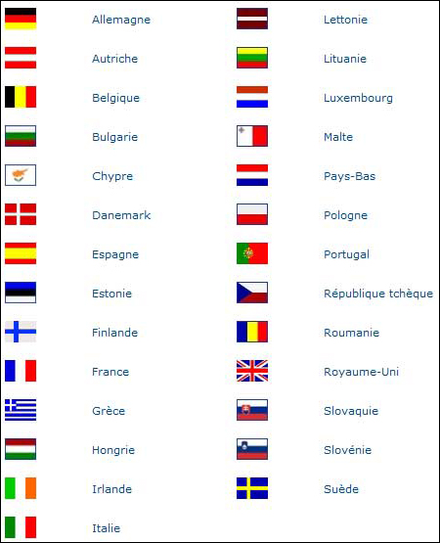

|  |  |  |  |  |  |  |  |
| --- | --- | --- | --- | --- | --- | --- | --- |
| c’est combien? |  | | | c’est...... | |  | |
| 2,10 euros | | 4,20 euros | 7,50 euros | | 50,00 euros | | 14,30 euros |
| 6,60 euros | | 9,80 euros | 10,90 euros | | 11,25 euros | | 5,55 euros |
| 12,25 euros | | 18,70 euros | 8,45 euros | | 3,32 euros | | 9,99 euros |
| 46,78 euros | | 79,56 euros | 122,23 euros | | 2345 euros | | 13 456 euros |

|  |  |  |  |
| --- | --- | --- | --- |
| c’est quel sport? |  | c’est |  |

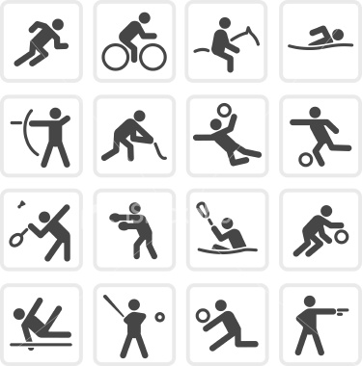

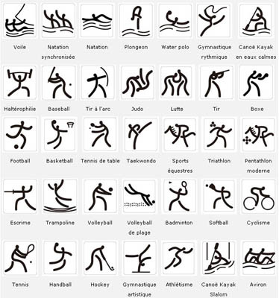

|  |  |  |
| --- | --- | --- |
| *[Aerobic sportive](http://www.noomba-sport.com/aerobic-sportive/clubs1.html) | *Danse | *[Bridge](http://www.noomba-sport.com/bridge/clubs1.html) |
| *[Alpinisme](http://www.noomba-sport.com/alpinisme/clubs1.html) | *[Football](http://www.noomba-sport.com/football/clubs1.html) | *[Canoë kayak](http://www.noomba-sport.com/canoe-kayak/clubs1.html) |
| *[Aqua gym](http://www.noomba-sport.com/aqua-gym/clubs1.html) | *[Golf](http://www.noomba-sport.com/golf/clubs1.html) | *[Course d’orientation](http://www.noomba-sport.com/course-orientation/clubs1.html) |
| *[Athlétisme](http://www.noomba-sport.com/athletisme/clubs1.html) | *[Gymnastique rythmique](http://www.noomba-sport.com/gymnastique-rythmique/clubs1.html) | *[Cyclisme sur route](http://www.noomba-sport.com/cyclisme-sur-route/clubs1.html) |
| *[Badminton](http://www.noomba-sport.com/badminton/clubs1.html) | *[Handball](http://www.noomba-sport.com/handball/clubs1.html) | *[Ski alpin](http://www.noomba-sport.com/ski-alpin/clubs1.html) |
| *[Ballet sur glace](http://www.noomba-sport.com/ballet-sur-glace/clubs1.html) | *[Handisport](http://www.noomba-sport.com/handisport/clubs1.html) | *[Ski de fond](http://www.noomba-sport.com/ski-de-fond/clubs1.html) |
| *[Baseball](http://www.noomba-sport.com/baseball/clubs1.html) | *[Hockey sur glace](http://www.noomba-sport.com/hockey-sur-glace/clubs1.html) | *[Ski nautique](http://www.noomba-sport.com/ski-nautique/clubs1.html) |
| *[Basket ball](http://www.noomba-sport.com/basket-ball/clubs1.html) | *[Karaté](http://www.noomba-sport.com/karate/clubs1.html) | *[Tennis](http://www.noomba-sport.com/tennis/clubs1.html) |
| *[Biathlon](http://www.noomba-sport.com/biathlon/clubs1.html) | *[Luge](http://www.noomba-sport.com/luge/clubs1.html) | *[Tennis de table](http://www.noomba-sport.com/tennis-de-table/clubs1.html) |
| *[Billard](http://www.noomba-sport.com/billard/clubs1.html) | *Lutte | *[Volley ball](http://www.noomba-sport.com/volley-ball/clubs1.html) |
| *[BMX](http://www.noomba-sport.com/bmx/clubs1.html) | *[Musculation](http://www.noomba-sport.com/musculation/clubs1.html) | *[Rallye](http://www.noomba-sport.com/rallye/clubs1.html) |
| *[Bowling](http://www.noomba-sport.com/bowling/clubs1.html) | *[Natation](http://www.noomba-sport.com/natation/clubs1.html) | *[Rugby](http://www.noomba-sport.com/rugby-a-xv/clubs1.html) |
| *[Boxe](http://www.noomba-sport.com/boxe-americaine/clubs1.html) | *[Patinage artistique](http://www.noomba-sport.com/patinage-artistique/clubs1.html) |  |

|  |  |  |
| --- | --- | --- |
| [Accrobranche](http://www.noomba-sport.com/accrobranche/clubs1.html) | [Modélisme](http://www.noomba-sport.com/modelisme/clubs1.html) | [Danses de salon](http://www.noomba-sport.com/danses-de-salon/clubs1.html) |
| [Aéromodélisme](http://www.noomba-sport.com/aeromodelisme/clubs1.html) | [Moto cross](http://www.noomba-sport.com/moto-cross/clubs1.html) | [Danses latines](http://www.noomba-sport.com/danses-latines/clubs1.html) |
| [Aérostation](http://www.noomba-sport.com/aerostation/clubs1.html) | [Moto vitesse](http://www.noomba-sport.com/moto-vitesse/clubs1.html) | [Danses standards](http://www.noomba-sport.com/danses-standards/clubs1.html) |
| [Aikido](http://www.noomba-sport.com/aikido/clubs1.html) | [Motoneige](http://www.noomba-sport.com/motoneige/clubs1.html) | [Danses swing](http://www.noomba-sport.com/danses-swing/clubs1.html) |
| [Apnée](http://www.noomba-sport.com/apnee/clubs1.html) | [Nage avec palmes](http://www.noomba-sport.com/nage-avec-palmes/clubs1.html) | [Deltaplane](http://www.noomba-sport.com/deltaplane/clubs1.html) |
| [Arts martiaux artistiques](http://www.noomba-sport.com/arts-martiaux-artistiques/clubs1.html) | [Nage en eau vive](http://www.noomba-sport.com/nage-en-eau-vive/clubs1.html) | [Disc Golf](http://www.noomba-sport.com/disc-golf/clubs1.html) |
| [Aviation](http://www.noomba-sport.com/aviation/clubs1.html) | [Naginata](http://www.noomba-sport.com/naginata/clubs1.html) | [Echecs](http://www.noomba-sport.com/echecs/clubs1.html) |
| [Aviron](http://www.noomba-sport.com/aviron/clubs1.html) | [Natation synchronisée](http://www.noomba-sport.com/natation-synchronisee/clubs1.html) | [Equitation](http://www.noomba-sport.com/equitation/clubs1.html) |
| [Baby foot](http://www.noomba-sport.com/baby-foot/clubs1.html) | [Nunchaku](http://www.noomba-sport.com/nunchaku/clubs1.html) | [Escalade](http://www.noomba-sport.com/escalade/clubs1.html) |
| [Ball trap](http://www.noomba-sport.com/ball-trap/clubs1.html) | [Parachutisme](http://www.noomba-sport.com/parachutisme/clubs1.html) | [Escrime](http://www.noomba-sport.com/escrime/clubs1.html) |
| [Baton défense](http://www.noomba-sport.com/baton-defense/clubs1.html) | [Parapente](http://www.noomba-sport.com/parapente/clubs1.html) | [Fléchettes](http://www.noomba-sport.com/flechettes/clubs1.html) |
| [Bébé nageur](http://www.noomba-sport.com/bebe-nageur/clubs1.html) | [Pêche](http://www.noomba-sport.com/peche/clubs1.html) | [Force athlétique](http://www.noomba-sport.com/force-athletique/clubs1.html) |
| [Boule lyonnaise](http://www.noomba-sport.com/boule-lyonnaise/clubs1.html) | [Pêche sous-marine](http://www.noomba-sport.com/peche-sous-marine/clubs1.html) | [Futsal](http://www.noomba-sport.com/futsal/clubs1.html) |
| [Canne de combat](http://www.noomba-sport.com/canne-de-combat/clubs1.html) | [Pelote basque](http://www.noomba-sport.com/pelote-basque/clubs1.html) | [Giraviation](http://www.noomba-sport.com/giraviation/clubs1.html) |
| [Canne défense](http://www.noomba-sport.com/canne-defense/clubs1.html) | [Pentathlon](http://www.noomba-sport.com/pentathlon/clubs1.html) | [Gymnastique artistique](http://www.noomba-sport.com/gymnastique-artistique/clubs1.html) |
| [Canyonisme](http://www.noomba-sport.com/canyonisme/clubs1.html) | [Pétanque](http://www.noomba-sport.com/petanque/clubs1.html) | [Gymnastique douce](http://www.noomba-sport.com/gymnastique-douce/clubs1.html) |
| [Cerf volant](http://www.noomba-sport.com/cerf-volant/clubs1.html) | [Planche à voile](http://www.noomba-sport.com/planche-a-voile/clubs1.html) | [Haltérophilie](http://www.noomba-sport.com/halterophilie/clubs1.html) |
| [Char à voile](http://www.noomba-sport.com/char-a-voile/clubs1.html) | [Plongée](http://www.noomba-sport.com/plongee/clubs1.html) | [Hockey subaquatique](http://www.noomba-sport.com/hockey-subaquatique/clubs1.html) |
| [Course à pied](http://www.noomba-sport.com/course-a-pied/clubs1.html) | [Plongeon](http://www.noomba-sport.com/plongeon/clubs1.html) | [Hockey sur gazon](http://www.noomba-sport.com/hockey-sur-gazon/clubs1.html) |
| [Cyclisme sur piste](http://www.noomba-sport.com/cyclisme-sur-piste/clubs1.html) | [Randonnée équestre](http://www.noomba-sport.com/randonnee-equestre/clubs1.html) | [Judo](http://www.noomba-sport.com/judo/clubs1.html) |
| [Danse classique](http://www.noomba-sport.com/danse-classique/clubs1.html) | [Randonnée pédestre](http://www.noomba-sport.com/randonnee-pedestre/clubs1.html) | [Ju-Jitsu traditionnel](http://www.noomba-sport.com/ju-jitsu-traditionnel/clubs1.html) |
| [Danse contemporaine](http://www.noomba-sport.com/danse-contemporaine/clubs1.html) | [Raquette à neige](http://www.noomba-sport.com/raquette-a-neige/clubs1.html) | [Karting](http://www.noomba-sport.com/karting/clubs1.html) |
| [Danse country](http://www.noomba-sport.com/danse-country/clubs1.html) | [Ski de randonnée](http://www.noomba-sport.com/ski-de-randonnee/clubs1.html) | [Lutte gréco-romaine](http://www.noomba-sport.com/lutte-greco-romaine/clubs1.html) |
| [Danse espagnole](http://www.noomba-sport.com/danse-espagnole/clubs1.html) | [Ski de vitesse](http://www.noomba-sport.com/ski-de-vitesse/clubs1.html) | [Lutte libre](http://www.noomba-sport.com/lutte-libre/clubs1.html) |
| [Danse indienne](http://www.noomba-sport.com/danse-indienne/clubs1.html) | [Ski sur herbe](http://www.noomba-sport.com/ski-sur-herbe/clubs1.html) | [Marche athlétique](http://www.noomba-sport.com/marche-athletique/clubs1.html) |
| [Danse jazz](http://www.noomba-sport.com/danse-jazz/clubs1.html) | [Spéléologie](http://www.noomba-sport.com/speleologie/clubs1.html) | [Trampoline](http://www.noomba-sport.com/trampoline/clubs1.html) |
| [Danse modern jazz](http://www.noomba-sport.com/danse-modern-jazz/clubs1.html) | [Danse sur glace](http://www.noomba-sport.com/danse-sur-glace/clubs1.html) | [Triathlon](http://www.noomba-sport.com/triathlon/clubs1.html) |
| [Danse orientale](http://www.noomba-sport.com/danse-orientale/clubs1.html) | [Danses caraïbes](http://www.noomba-sport.com/danses-caraibes/clubs1.html) | [Voile](http://www.noomba-sport.com/voile/clubs1.html) |
| [Vol à voile](http://www.noomba-sport.com/vol-a-voile/clubs1.html) | [VTT](http://www.noomba-sport.com/vtt/clubs1.html) |  |

|  |  |  |  |
| --- | --- | --- | --- |
| c’est quel fruit? |  | c’est |  |

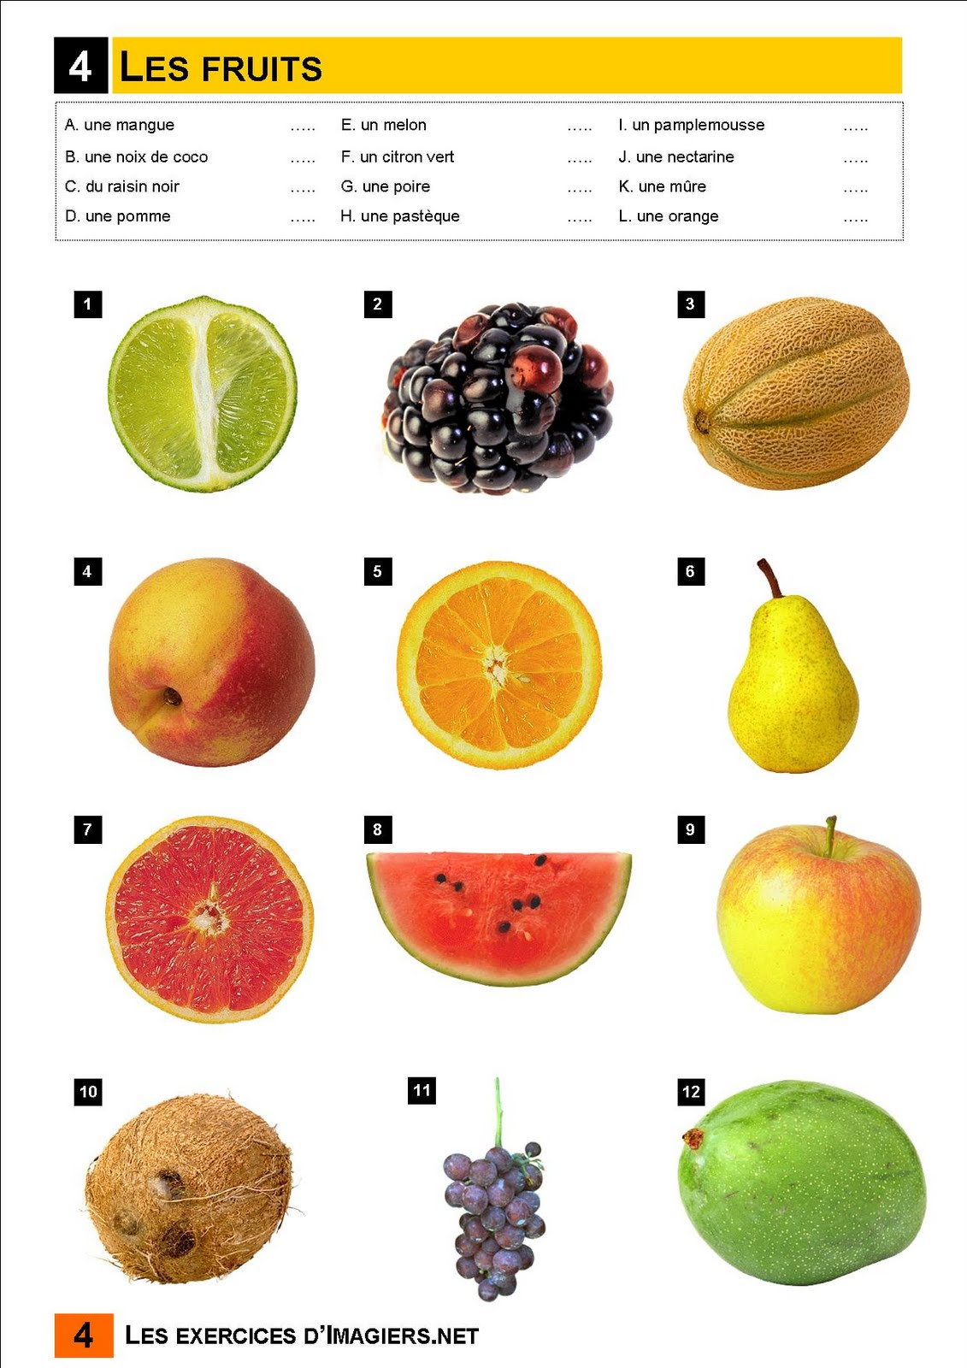

|  |  |  |  |
| --- | --- | --- | --- |
| c’est quel légume? |  | c’est |  |

