74.Thomas et la télé. Il aime la télé ? Quel âge a Thomas maintenant ?

75.Le pére et Thomas se ressemblent ?

Expliquez la fin :
J’espère quand même que, mises bout à bout, toutes leurs petites joies, Snoopy, un bain tiède, la caresse d’un chat, un rayon de soleil, un ballon, une promenade à Carrefour, les sourires des autres, les petites voitures, les frites… auront rendu le séjour supportable.

76.Expliquez ce chapitre à l’aide de cette image :
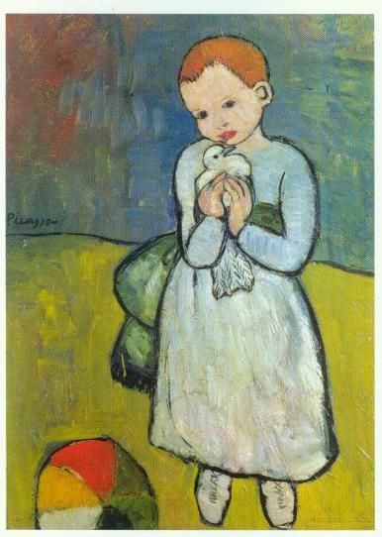

77.Quel âge a Thomas ? Que veut dire « tuteur » ? Expliquez son rôle ! Thomas, que pense-t-il de l’argent ? À la fin du chapitre, que dit Thomas à son père ?

78. Commentez : Un enfant handicapé a le droit de vote.

Où on va papa ; la fin du livre ; prénom..........................................résultat..................sur 20

76. Berätta om den vita duvan.

78. Le droit de vote. Thomas a le droit de voter. Qui va-t-il choisir ?

80. Dans ce chapitre Thomas parle avec Martine. Qui est Martine ? Expliquez ce qu’elle fait et ce qu’elle symbolise.

81. Le coup de téléphone. Thomas et son père se parlent au téléphone. Comment est la conversation ? De quoi parlent-ils ?

82. Thomas ne va pas très bien. Qu’est-ce qui se passe ? Que font-ils à l’institut pour le calmer ?

83. Le père a retrouvé des faire-part de naissance. Expliquez ce qu’il dit dans ce chapitre.

84.Pourquoi le père n’aime-t-il pas les faire-part de naissance des autres ?

85. Expliquez ce chapitre à l’aide des mots suivants : berätta om detta kapitel med hjälp av följande ord :

fauteuil roulant | voûté | conversation
tire la langue aux éducateurs | mouvements de danse | excentricités
bêtises | indatables | jugé

86. Expliquez comment ça se passe à l’IMP

87. Il y a une manifestation sportive à l’IMP. Que fait Thomas ?

88. Que pensait le père des enfants quand il était jeune ?

Expliquez cette phrase : Je n’ai pas eu de chance. J’ai joué à la loterie génétique, j’ai perdu.

89. Comment se termine le livre ? Que dit-il à cette dernière page ?

Quel est votre avis personnel du livre? Expliquez et justifiez vos réponses !
________________________________________________________________________________________________________

________________________________________________________________________________________________________

________________________________________________________________________________________________________

________________________________________________________________________________________________________

________________________________________________________________________________________________________

________________________________________________________________________________________________________

________________________________________________________________________________________________________

________________________________________________________________________________________________________

________________________________________________________________________________________________________

________________________________________________________________________________________________________

________________________________________________________________________________________________________

________________________________________________________________________________________________________

________________________________________________________________________________________________________

________________________________________________________________________________________________________

________________________________________________________________________________________________________

________________________________________________________________________________________________________

________________________________________________________________________________________________________

________________________________________________________________________________________________________

________________________________________________________________________________________________________

________________________________________________________________________________________________________

________________________________________________________________________________________________________

________________________________________________________________________________________________________

________________________________________________________________________________________________________

________________________________________________________________________________________________________

________________________________________________________________________________________________________

________________________________________________________________________________________________________

________________________________________________________________________________________________________

________________________________________________________________________________________________________

________________________________________________________________________________________________________

________________________________________________________________________________________________________

________________________________________________________________________________________________________

________________________________________________________________________________________________________

________________________________________________________________________________________________________

________________________________________________________________________________________________________

________________________________________________________________________________________________________

________________________________________________________________________________________________________

________________________________________________________________________________________________________

________________________________________________________________________________________________________

________________________________________________________________________________________________________

________________________________________________________________________________________________________

________________________________________________________________________________________________________

________________________________________________________________________________________________________

________________________________________________________________________________________________________

________________________________________________________________________________________________________

________________________________________________________________________________________________________

________________________________________________________________________________________________________

________________________________________________________________________________________________________

________________________________________________________________________________________________________

________________________________________________________________________________________________________

________________________________________________________________________________________________________

________________________________________________________________________________________________________

________________________________________________________________________________________________________

________________________________________________________________________________________________________

________________________________________________________________________________________________________

________________________________________________________________________________________________________

________________________________________________________________________________________________________

________________________________________________________________________________________________________

________________________________________________________________________________________________________

________________________________________________________________________________________________________

________________________________________________________________________________________________________

________________________________________________________________________________________________________

________________________________________________________________________________________________________

________________________________________________________________________________________________________

________________________________________________________________________________________________________

________________________________________________________________________________________________________

________________________________________________________________________________________________________

________________________________________________________________________________________________________

________________________________________________________________________________________________________

________________________________________________________________________________________________________

________________________________________________________________________________________________________

________________________________________________________________________________________________________

________________________________________________________________________________________________________

________________________________________________________________________________________________________

________________________________________________________________________________________________________

________________________________________________________________________________________________________

________________________________________________________________________________________________________

________________________________________________________________________________________________________

________________________________________________________________________________________________________

________________________________________________________________________________________________________

________________________________________________________________________________________________________

________________________________________________________________________________________________________

________________________________________________________________________________________________________

________________________________________________________________________________________________________

________________________________________________________________________________________________________

________________________________________________________________________________________________________

________________________________________________________________________________________________________

________________________________________________________________________________________________________

________________________________________________________________________________________________________

________________________________________________________________________________________________________

________________________________________________________________________________________________________

________________________________________________________________________________________________________

________________________________________________________________________________________________________

________________________________________________________________________________________________________

________________________________________________________________________________________________________

________________________________________________________________________________________________________

________________________________________________________________________________________________________

________________________________________________________________________________________________________

________________________________________________________________________________________________________

________________________________________________________________________________________________________

________________________________________________________________________________________________________

________________________________________________________________________________________________________

________________________________________________________________________________________________________

________________________________________________________________________________________________________

________________________________________________________________________________________________________

________________________________________________________________________________________________________

________________________________________________________________________________________________________

________________________________________________________________________________________________________

________________________________________________________________________________________________________

